SECONDARY CURRICULUM
Year 7 Learning Journey 2022-23

Our Secondary Curriculum is driven by the aim to nurture and develop 9 essential ‘Key Life Tools’ (refer to Gosden Graduate Toolbox Doc) in our learners. These ‘Life Tools’ form our ‘Gosden Graduate Toolkit’ and we believe they are essential in preparing our Gosden Learners for their individual pathways post 16. Through ‘tooling up’ our learners we aim to develop a lifelong love of learning, building in them resilience and grit, so that when they leave Gosden House School they are better equipped to face life’s challenges in a world that is forever changing.

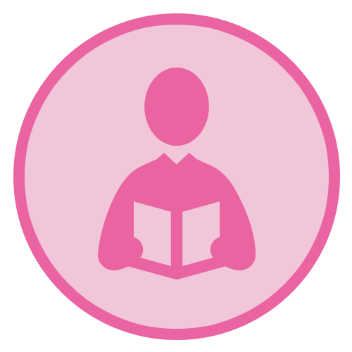 |  |  | 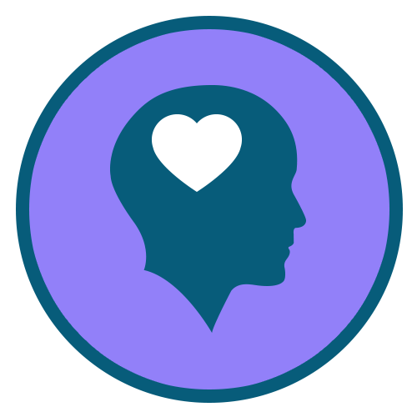 | 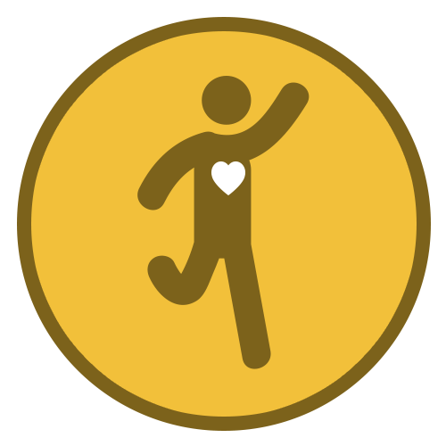 | 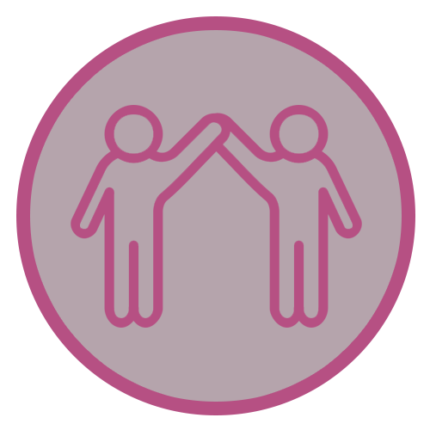 |  | 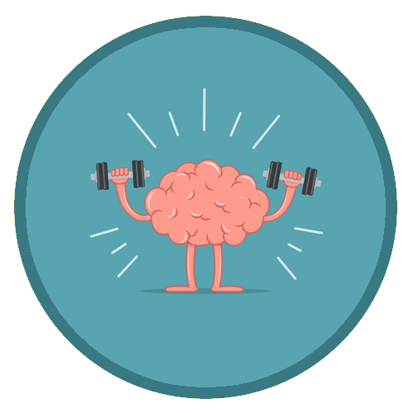
Functional  Literacy  Skills | Functional  Numeracy  Skills | Functional  ICT  Skills | Emotional  Wellbeing | Healthy Lifestyle | Healthy Relationships | Life Skills | Learning Muscles | Employability Skills and Qualifications

Subject | AUTUMN |  | SPRING |  |  | SUMMER
Functional Maths | Throughout their Maths learning journey, our learners will develop skills in the following areas;  Number – Counting forwards and backwards, addition, subtraction, multiplication, division, fractions and place value, number system.  Measure – Time, money, weight, length, capacity and temperature  Geometry – Properties of 2D and 3D shapes including positions and directions  Statistics – Carrying out surveys, interpreting data and presenting data in charts and graphs  Functional Skills – Practical Maths in everyday situations throughout the curriculum.  HOME LEARNING OPPORTUNITIES  Lots of handling money opportunities , spending, budgeting, cooking together and saving pocket money, number based online and board games , wearing a watch and talking about time including days of the week, months and the seasons, reading timetables.  Free online Maths games - Top Marks, Oxford Owl, and Oak National Academy.  Homework  We believe that the purpose of homework is to allow our learners to further their learning in a creative and explorative way. Homework will be set every Friday and will be due the following Friday, it will be a practical activity that will allow them to consolidate their learning from that week. If your child is finding it tricky to complete their homework, please do get in touch as we can support them with their homework at school.
Functional Literacy | As part of their Literacy learning journey, our learners develop their reading, writing and spoken language skills. Our Learners will be exposed to a wide variety of texts such as; Stories, Poetry, Non-fiction and Plays (including Shakespeare). These texts will be used as ‘vessels’ to enable our learners to access a modified and individualised National Curriculum. A further aspect of their Literacy learning journey, will be explicit lessons dedicated to the teaching of spelling, punctuation and grammar. This will enable our learners to develop their skills in these areas, which they can then use throughout the rest of their learning journey.  HOME LEARNING OPPORTUNITIES  Speaking – answer the phone at home. Practise speaking on the phone by ordering a take-away or booking an appointment.  Listening – Listen to the news (Newsround) on either the radio or the TV; ask questions after listening to gauge their understanding.  Reading – Support with reading food labels. timetables, road signs, instructions.  Writing – Encourage writing thank you notes, postcards, keeping a diary.  Homework  We believe that the purpose of homework is to allow our learners to further their learning in a creative and explorative way. Homework will be set every Friday and will be due the following Friday, it will be a written task that will allow them to consolidate their learning from that week. If your child is finding it tricky to complete their homework, please do get in touch as we can support them with their homework at school.
Computing | Within the Secondary Department, we deliver the Computing Curriculum throughout all subjects. This allows our learners to have many opportunities to engage with technology in a meaningful way, which will allow them to develop their functional ICT skills.  HOME RESOURCES  Touch Typing Practise – BBC Dance Mat  Microsoft Powerpoint – make Powerpoints on areas of interest and then present them to family.  With support and guidance research ‘Our World’ topics and then share research with teacher.  NSPCC online, Child net, internetmatter.com.  Our E-safety Co-ordinator is also available to support and guide parents regarding keeping happy and safe online.
Citizenship | As part of their Citizenship learning journey, our learners will investigate the real meaning of Citizenship. They will also explore the question; what makes a good citizen? They will consider their environments and the people around them. We will consider some of the things we do at home, at school, in our towns and villages, to improve our own lives and the lives of others. We will also think of ways to be a better citizen and work on some special projects to help our school.
Our World | Through the delivery of Our World which incorporates History, Geography, Languages and Science. Our aim is to encourage curiosity and creativity in our learners and provide them with real life opportunities for discovery and exploration. Each term the Learners will be presented with a question that will spark their creativity and curiosity for the chosen topic. This project-based approach supports our learners to develop all of their Learning Muscles.
 | Movement and Migration  Key Question – Why do living things migrate?  Please see below some examples of areas that we will aim to cover. As there will be many opportunities for our learners to take the lead in their project, some of the topics will arise during the planning stages of the project.  History – The Windrush Generation  Geography – Population and Urbanization  Science – Animal Migration & Adaptation  Languages – Different languages spoken in the United Kingdom |  | Climate Change  Key Question – How are we damaging our world?  Please see below some examples of areas that we will aim to cover. As there will be many opportunities for our learners to take the lead in their project, some of the topics will arise during the planning stages of the project.  History – The Ice Age  Geography – Climates  Science – Weather  Languages – Explore the languages and cultures of countries across the globe. |  |  | Gosden House  What would it have been like living in Gosden House during the Georgian Period?  Please see below some examples of areas that we will aim to cover. As there will be many opportunities for our learners to take the lead in their project, some of the topics will arise during the planning stages of the project.  History – Life of children during the Georgian Period.  Geography – Comparison of the land surrounding Gosden.  Science – Forces and Materials.  Languages – Explore the languages of the Georgian Period; English, Latin, French and Italian.
P.S.H.E.E/  (Personal, Social, Health and Economic Education) | Autumn 1  My World and the Wider World  Our leaners will explore the idea of community, and consider the benefits of being part of a community. | Autumn 2  Me and My Relationships  Our leaners will explore the idea of role models, and develop their understanding of what makes a positive role model. | Spring 1  Health Lifestyle and Wellbeing  Our learners will explore mental health, and will develop their understanding of how to support their own mental health. |  | Spring 2  Relationships and Sex Education  Our learners will explore the term relationships, and will develop their understanding of different types of relationships. | Summer 1  Relationships and Sex Education  Our learners will explore the term puberty, and will develop their understanding of how our bodies change during puberty. |  | Summer 2  Life Skills  Our learners will develop their Life Skills in a range of areas from cooking to shopping.
Science | Our Science curriculum is taught through ‘Our World’. As part of this project-based learning, our learners will be able to access the Science National Curriculum through discovery and exploration. At the start of Year 7 our learners will take part in a Learning Power workshop – My Amazing Brain. Through this workshop our learners will explore the areas of the brain, their functions and the importance of looking after our brains. Please see below some examples of areas that we will aim to cover. As there will be many opportunities for our learners to take the lead in their project, some of the topics will arise during the planning stages of the project.
 | Movement and Migration  Animal Migration and Adaptation  Evolution and Inheritance  Food chains |  | Climate Change  Weather Systems  The Water Cycle  Pollution |  |  | Gosden House  Forces  Materials  Steam Power
R.E. | What does it mean to be a Hindu?  to investigate the religious practices of Hindus and how these influence home and family life, linking them with important Hindu beliefs.  Why do Christians call God ‘Father’  To help pupils to understand some things that Christians believe about God and his nature, using images from the Old Testament & the person of Jesus. It should include a specific study about God as Jesus portrays him in the parable of the Prodigal Son / Loving Father. |  | How did Jesus change lives?  to explore some of the most important miracles of Jesus, and how people were changed physically and emotionally by encountering him, but also how these encounters demonstrate, for Christians, that Jesus is God’s Son – and is still changing lives today  Why do Christians share communion/The Easter Story to help children understand that communion is an act of remembrance, sharing and reflection for Christians focusing on the belief that Jesus died so that there could be a new relationship between |  |  | How can we live together in one world  To consider how understanding the things that different people believe might help us to live together more harmoniously. During this unit, pupils should develop their concept of a global community, and recognise how people of many different beliefs, cultures and traditions should live together and learn from each other.  How can church help us to understand Christian belief  to explore aspects of communion and baptism in two different Christian denominations, and to think about what the similarities and differences show about Christian belief. Pupils will need a basic understanding of both communion and baptism in order to access the learning in this unit.
Creative Arts | Through Music, Drama and Art; the learners are exploring artists who work with the environment. Beachcombers who make jewelry and art out of what they find washed up on the beach. Paul Nicklen, a photographer who captures the effects of climate change. In Music, the learners are exploring water through different styles of music and making their own instruments out of recycled materials. In Drama, we are exploring environment through our body and movement. Also, the learners are performing their own speeches regarding climate change taking inspiration from Greta Thunberg.
P.E. | As part of their PE journey, our learners will be exposed to a range of different sports. They will learn skills related to each sport, which will enable them to enhance their abilities within that sport. They will explore the importance of a healthy lifestyle, and how this can be maintained.
 | Autumn Term  Hockey and Multi-skills |  |  | Spring Term  Kurling and Trampolining |  |  | Summer Term  Rounders and Athletics
Textiles | As part of their DT journey, our learners will have a term of Textiles. They will explore different techniques to use for sewing and will use these new skills in their own creations.
Food Studies | Each year group will have a term of Food studies. We will be looking at basic skills, hygiene, and cooking skills. We will be looking at healthy eating, a balanced diet and different food groups.
Swimming | Each year group will have a term of swimming. We will be looking at water safety, swimming skills and distance badges
Enrichment Programme | Enrichment activities play an essential part in enhancing the learning experiences and school life of our learners. These are aimed at developing their life tools including healthy relationships, emotional wellbeing and life skills. Learners are able to select the activities they would like to do, this helps them to further develop their Learning Muscles and become lifelong resilient Learners.

