SECONDARY CURRICULUM
Year 8 Learning Journey 2022-23

Our Secondary Curriculum is driven by the aim to nurture and develop 9 essential ‘Key Life Tools’ (refer to Gosden Graduate Toolbox Doc) in our learners. These ‘Life Tools’ form our ‘Gosden Graduate Toolkit’ and we believe they are essential in preparing our Gosden Learners for their individual pathways post 16. Through ‘tooling up’ our learners we aim to develop a lifelong love of learning, building in them resilience and grit, so that when they leave Gosden House School they are better equipped to face life’s challenges in a world that is forever changing.

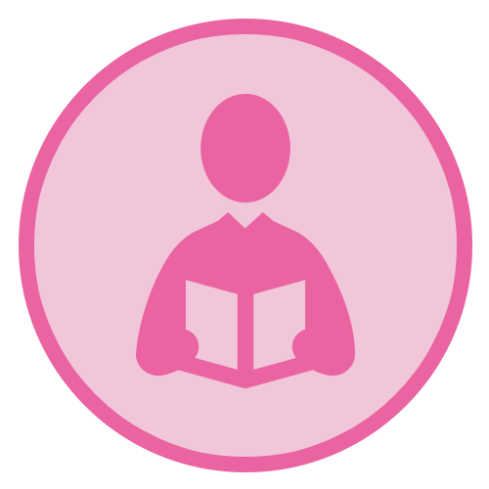 |  |  | 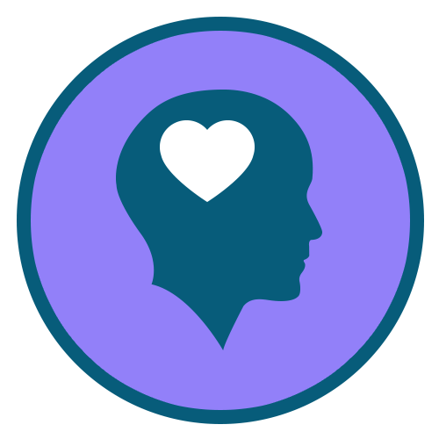 | 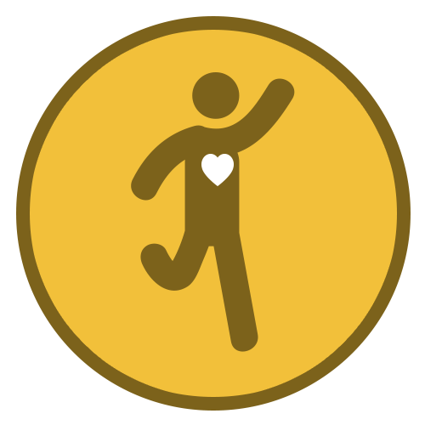 | 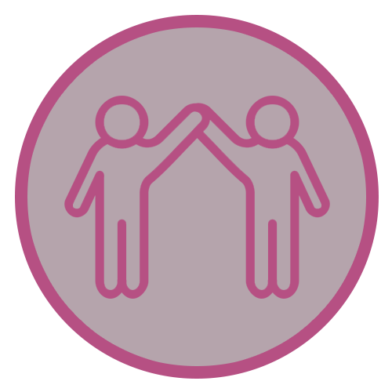 |  | 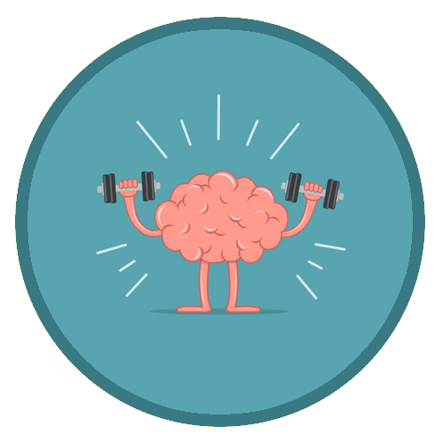
Functional  Literacy  Skills | Functional  Numeracy  Skills | Functional  ICT  Skills | Emotional  Wellbeing | Healthy Lifestyle | Healthy Relationships | Life Skills | Learning Muscles | Employability Skills and Qualifications

Subject | AUTUMN | SPRING | SUMMER
Functional Maths | Throughout their Maths learning journey, our learners will develop skills in the following areas;  Number – Counting forwards and backwards, addition, subtraction, multiplication, division, fractions and place value, number system.  Measure – Time, money, weight, length, capacity and temperature  Geometry – Properties of 2D and 3D shapes including positions and directions  Statistics – Carrying out surveys, interpreting data and presenting data in charts and graphs  Functional Skills – Practical Maths in everyday situations throughout the curriculum.  HOME LEARNING OPPORTUNITIES  Lots of handling money opportunities , spending, budgeting and saving pocket money, number based online and board games , wearing a watch and talking about time including days of the week, months and the seasons, reading timetables.  Free online Maths games - Top Marks, Oxford Owl, and Oak National Academy.  Homework  We believe that the purpose of homework is to allow our learners to further their learning in a creative and explorative way. Homework will be set every Friday and will be due the following Friday, it will be a practical activity that will allow them to consolidate their learning from that week. If your child is finding it tricky to complete their homework, please do get in touch as we can support them with their homework at school.
Functional Literacy | As part of their Literacy learning journey, our learners develop their reading, writing and spoken language skills. Our Learners will be exposed to a wide variety of texts such as; Stories, Poetry, Non-fiction and Plays (including Shakespeare). These texts will be used as ‘vessels’ to enable our learners to access a modified and individualised National Curriculum. A further aspect of their Literacy learning journey, will be explicit lessons dedicated to the teaching of spelling, punctuation and grammar. This will enable our learners to develop their skills in these areas, which they can then use throughout the rest of their learning journey.  HOME LEARNING OPPORTUNITIES  Speaking – answer the phone at home. Practise speaking on the phone by ordering a take-away or booking an appointment.  Listening – Listen to the news on either the radio or the TV; ask questions after listening to gauge their understanding.  Reading – Support with reading food labels. timetables, road signs, instructions.  Writing – Encourage writing thank you notes, postcards, keeping a diary.  Homework  We believe that the purpose of homework is to allow our learners to further their learning in a creative and explorative way. Homework will be set every Friday and will be due the following Friday, it will be a written task that will allow them to consolidate their learning from that week. If your child is finding it tricky to complete their homework, please do get in touch as we can support them with their homework at school.
Computing | Within the Secondary Department, we deliver the Computing Curriculum throughout all subjects. This allows our learners to have many opportunities to engage with technology in a meaningful way, which will allow them to develop their functional ICT skills.  HOME RESOURCES  NSPCC online, Child net, internetmatter.com. BBC online - Dance Mat Typing game  Our E-safety Co-ordinator is also available to support and guide parents.
Citizenship | As part of their Citizenship learning journey, our learners will investigate the real meaning of Citizenship. They will also explore the question; what makes a good citizen? They will consider their environments and the people around them. We will consider some of the things we do at home, at school, in our towns and villages, to improve our own lives and the lives of others. We will also think of ways to be a better citizen and work on some special projects to help our school.
Our World | Through the delivery of Our World which incorporates History, Geography, Languages and Science. Our aim is to encourage curiosity and creativity in our learners and provide them with real life opportunities for discovery and exploration. Each term the Learners will be presented with a question that will spark their creativity and curiosity for the chosen topic. This project-based approach supports our learners to develop all of their Learning Muscles.
 | Key Question –  Why do we have wars?  Please see below some examples of areas that we will aim to cover. As there will be many opportunities for our learners to take the lead in their project, some of the topics will arise during the planning stages of the project.  History –  - Holocaust  - Word War I & II  - Ukraine  Geography –  - Berlin wall  - Changes in countries  - Looking at countries within Europe  Science –  - The brain and my senses  - Electricity  - Soundwaves  Languages –  - German  - Experience Language and Culture  - Languages within Europe | Key Question –  Where did the dinosaurs go?  Please see below some examples of areas that we will aim to cover. As there will be many opportunities for our learners to take the lead in their project, some of the topics will arise during the planning stages of the project.  History –  - Mary Anning ? Who is she?  - How was each species of dinosaur different?  - How archaeology has changed over time.  Geography –  - Comparison of America & UK  - Location of where dinosaurs were discovered  - Rocks – geology  Science – Amazing scientists-  - Mary Anning – Fossils  - Food chains  - Adaptations  - Carnivores, herbivores, omnivores | Local History Study  Guildford  Please see below some examples of areas that we will aim to cover. As there will be many opportunities for our learners to take the lead in their project, some of the topics will arise during the planning stages of the project.  History –  - Famous residents of Guildford  - History of the city  - Castles  Geography –  - Where is Guildford Castle?  - Where does the River Wey start and finish?  - What is the importance of the river?  Science –  - Crazy Creations Workshops  Pupils will work together to create their own dams and locks, testing different forces and making predictions.
P.S.H.E.E/  (Personal, Social, Health and Economic Education) | My world & the wider world  I know what a community is  I can name some examples of a community  I understand the benefits of a specific community  I can reflect on a task I have achieved  I can give an example of a task I have achieved  Me and my relationships  I can ask for help to solve a disagreements  I can think of some ways to solve a specific disagreement with support  I know what a role model is  I understand there can be good and bad role models  I can categorise characters into good and bad role models  I can work in a team with a range of peers | Health lifestyle and wellbeing  I can name different kinds of diets i.e vegetarian  I know how germs can be passed along  I know why I need to wash my hands  I know that medicine can help cure some illnesses  I know it is ok to make mistakes.  I know that making mistakes is part of learning.  I can say something I am good at  I know some activities I can do to make me feel calm  I know what mindfulness is  I know some ways I can feel mindful  I know what metal health is  I know my mental health is as important as my physical health  I know some ways to care for my mental health  Relationships and Sex Education  - Puberty  - Periods & wet dreams  - Naming body parts and sexual organs | Life skills  I know how to ask for help if I have a problem online.  I can make a snack for myself or others  I can make a hot drink independently  I can write a simple shopping list  I can call the emergency services independently  Relationships and Sex Education  - Body image  - Consent/privacy  - Keeping safe  - Relationships
R.E. | Judaism  Who is a Jew?  Looking at the difference and diversity with the Jewish community in the UK today.  Pupils will gain an insight into different groups within Judaism, the variety of practice and the importance of the synagogue as focal point for Jewish religious and social life in UK today. | Islam  How does Ramadan and the Hajj help Muslims to develop self-discipline in their everyday life?  Pupils will examine what it means to be a Muslim in today’s society including how Ramadan and the Hajj provide opportunities to express self-discipline and help Muslim’s life out their faith in daily life | Christianity  How is the Bible relevant to Christians today?  This unit provides opportunities for pupils to explore the significance of the Bible for the Christian community and its wider  impact on western culture. It builds on pupils’ knowledge and understanding of the Bible and enables them to examine how the Bible can be used  and interpreted in different ways within historical, cultural and contemporary contexts.
Creative Arts | In the summer term Year 8 will take part in a creative arts carousel. This will include drama, music and art sessions, focusing on the ‘Our World’ theme of Guildford and rivers.
P.E. | Swimming, Netball & Trampolining | Multiskills & Football | Rounders & Athletics
DT | In the spring term Year 8 will be doing DT, they will be learning sewing skills and will design and create their own textiles product.
Food Studies | In spring term we will be looking at basic skills, hygiene, and cooking skills. We will be looking at healthy eating, a balanced diet and different food groups.
Swimming | Each year group will have a term of swimming. We will be looking at water safety, swimming skills and distance badges
Enrichment Programme | Enrichment activities play an essential part in enhancing the learning experiences and school life of our learners. These are aimed at developing their life tools including healthy relationships, emotional wellbeing and life skills. Learners are able to select the activities they would like to do, this helps them to further develop their Learning Muscles and become lifelong resilient Learners.

