SECONDARY CURRICULUM
Year 9 Learning Journey 2022-23

Our Secondary Curriculum is driven by the aim to nurture and develop 9 essential ‘Key Life Tools’ (refer to Gosden Graduate Toolbox Doc) in our learners. These ‘Life Tools’ form our ‘Gosden Graduate Toolkit’ and we believe they are essential in preparing our Gosden Learners for their individual pathways post 16. Through ‘tooling up’ our learners we aim to develop a lifelong love of learning, building in them resilience and grit, so that when they leave Gosden House School they are better equipped to face life’s challenges in a world that is forever changing.

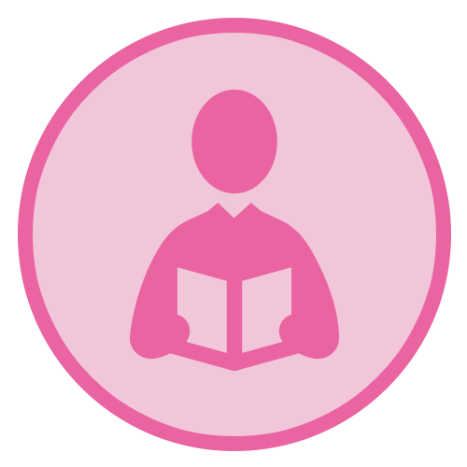 |  | 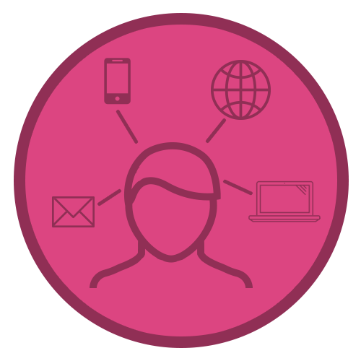 | 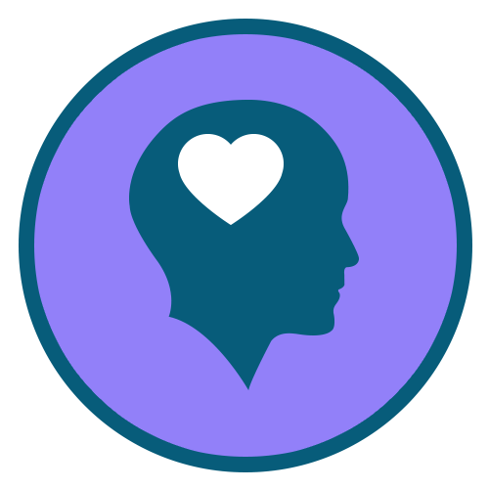 | 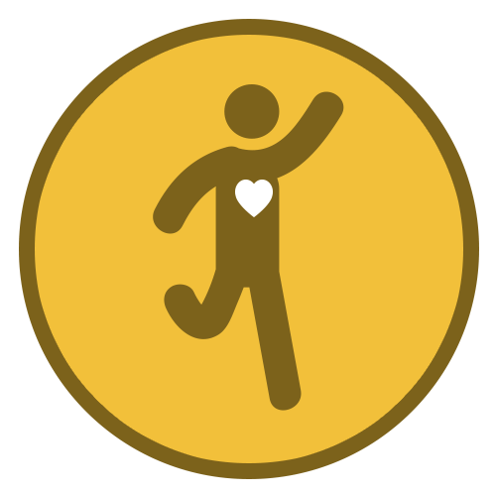 | 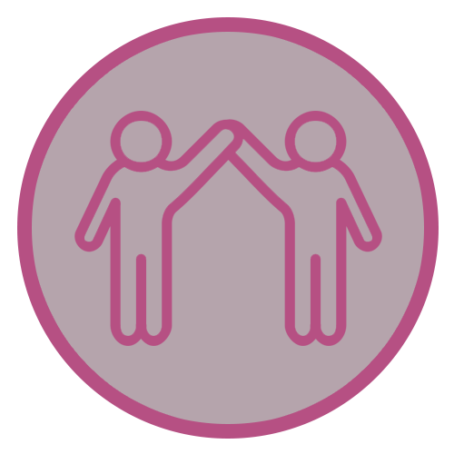 |  | 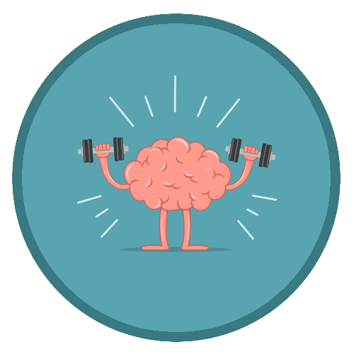
Functional  Literacy  Skills | Functional  Numeracy  Skills | Functional  ICT  Skills | Emotional  Wellbeing | Healthy Lifestyle | Healthy Relationships | Life Skills | Learning Muscles | Employability Skills and Qualifications

Subject | AUTUMN | SPRING | SUMMER
Functional Maths | Throughout their Maths learning journey, our learners will develop skills in the following areas;  Number – Counting forwards and backwards, addition, subtraction, multiplication, division, fractions and place value, number system.  Measure – Time, money, weight, length, capacity and temperature  Geometry – Properties of 2D and 3D shapes including positions and directions  Statistics – Carrying out surveys, interpreting data and presenting data in charts and graphs  Functional Skills – Practical Maths in everyday situations throughout the curriculum.  HOME LEARNING OPPORTUNITIES  Lots of handling money opportunities , spending, budgeting and saving pocket money, number based online and board games , wearing a watch and talking about time including days of the week, months and the seasons, reading timetables.  Free online Maths games - Top Marks, Oxford Owl, and Oak National Academy.  Homework  We believe that the purpose of homework is to allow our learners to further their learning in a creative and explorative way. Homework will be set every Friday and will be due the following Friday, it will be a practical activity that will allow them to consolidate their learning from that week. If your child is finding it tricky to complete their homework, please do get in touch as we can support them with their homework at school.
Functional Literacy | As part of their Literacy learning journey, our learners develop their reading, writing and spoken language skills. Our Learners will be exposed to a wide variety of texts such as; Stories, Poetry, Non-fiction and Plays (including Shakespeare). These texts will be used as ‘vessels’ to enable our learners to access a modified and individualised National Curriculum. A further aspect of their Literacy learning journey, will be explicit lessons dedicated to the teaching of spelling, punctuation and grammar. This will enable our learners to develop their skills in these areas, which they can then use throughout the rest of their learning journey.  HOME LEARNING OPPORTUNITIES  Speaking – answer the phone at home. Practise speaking on the phone by ordering a take-away or booking an appointment.  Listening – Listen to the news on either the radio or the TV; ask questions after listening to gauge their understanding.  Reading – Support with reading food labels. timetables, road signs, instructions.  Writing – Encourage writing thank you notes, postcards, keeping a diary.  Homework  We believe that the purpose of homework is to allow our learners to further their learning in a creative and explorative way. Homework will be set every Friday and will be due the following Friday, it will be a written task that will allow them to consolidate their learning from that week. If your child is finding it tricky to complete their homework, please do get in touch as we can support them with their homework at school.
Computing | Within the Secondary Department, we deliver the Computing Curriculum throughout all subjects. This allows our learners to have many opportunities to engage with technology in a meaningful way, which will allow them to develop their functional ICT skills.  HOME RESOURCES  NSPCC online, Child net, internetmatter.com.  Our E-safety Co-ordinator is also available to support and guide parents.
Citizenship | As part of their Citizenship learning journey, our learners will investigate the real meaning of Citizenship. They will also explore the question; what makes a good citizen? They will consider their environments and the people around them. We will consider some of the things we do at home, at school, in our towns and villages, to improve our own lives and the lives of others. We will also think of ways to be a better citizen and work on some special projects to help our school.
Our World | Through the delivery of Our World which incorporates History, Geography, Languages and Science. Our aim is to encourage curiosity and creativity in our learners and provide them with real life opportunities for discovery and exploration. Each term the Learners will be presented with a question that will spark their creativity and curiosity for the chosen topic. This project-based approach supports our learners to develop all of their Learning Muscles.
 | Human rights  Key Question – Why are rights so important?  Please see below some examples of areas that we will aim to cover. As there will be many opportunities for our learners to take the lead in their project, some of the topics will arise during the planning stages of the project.  History – Human Rights, Slave trade, Suffragettes, Stonewall, Equal Pay, EQUALITY  Geography – Is fair trade even fair?  Borders of countries – how they’ve changed  Science – The brain, tectonic plates, reproductive system, my body, keeping healthy  Languages – Different languages spoken in the United Kingdom | Key Question –  What are microbes?  Please see below some examples of areas that we will aim to cover. As there will be many opportunities for our learners to take the lead in their project, some of the topics will arise during the planning stages of the project.  History – Medicine through time.  - Find out about the life and times of Edward Jenner who created the world’s first vaccine.  - Learn about Alexander Flemming  - COVID-19  Geography – Spread of malaria and the impact it has on people, the economy and the environment. Comparison on UK and Africa malaria cases. Students then look at the ways in which it can be controlled. Learn about the work of UNICEF  Science – What are microbes? Virus, bacteria and fungi.  Hand hygiene, Respitory Hygiene  - Sneezing – how do germs spread.  - Oral hygiene What are vaccines and anti-biotics  - Food hygiene – food poisoning  - Parasites  - Useful microbes | Key questions  Would you have liked to live in Tudor times?  Please see below some examples of areas that we will aim to cover. As there will be many opportunities for our learners to take the lead in their project, some of the topics will arise during the planning stages of the project.  History – Tudor Britain, Hampton Court Palace, Spanish Armada, Christopher Columbus  Geography –. Where is Hampton court?  What is the importance of the river?  The British Empire – allies and enemies. Trade Routes  Science – Electricity wasn’t invented in Tudor times, what sources of light could the Tudors have used? How could the Tudors make light so they could see at night? Why do you think electric lights are better than other light sources for lighting homes?
P.S.H.E.E/  (Personal, Social, Health and Economic Education) | Me and my relationships  I know what bullying is  I know that is wrong to bully someone  I know how to ask for help if I am being bullied  I know how to be kind to others  I know what racism is  I know it is wrong to treat people differently because of the colour of their skin  Life skills  I know how to ask for help if something online worries me  I know what personal hygiene is  I know how to use deodorant  I know when I need to wash myself  I can make a hot drink independently | My world & the wider world  I can name some local communities  I can think of a community I would like to join  I can celebrate my own mistake  I know that I can keep trying when I make a mistake  I can plan again when I have made a mistake (task orientated)  Relationships and Sex Education | Health lifestyle and wellbeing  I can sequence a familiar routine  I can plan my bedtime routine with support  I can plan my morning routine with support  I know that there are no ‘good’ or ‘bad’ foods (all food gives you energy and is OK in balance)  I know that food gives me energy  I know that my body is not the most important part of me  I know what mindfulness is  I know some ways I can feel mindful  I know what metal health is  I know my mental health is as important as my physical health  I know some ways to care for my mental health  Relationships and Sex Education
Science | Our Science curriculum is taught through ‘Our World’. As part of this project-based learning, our learners will be able to access the Science National Curriculum through discovery and exploration. At the start of Year 9 our learners will take part in a Learning Power workshop – My Amazing Brain. Through this workshop our learners will explore the areas of the brain, their functions and the importance of looking after our brains. Please see below some examples of areas that we will aim to cover. As there will be many opportunities for our learners to take the lead in their project, some of the topics will arise during the planning stages of the project.
R.E. | What does it mean to be religious?  Group work to investigate a religion that they haven’t studied before (Islam, Buddhism, Judaism, Sikhism). Report back to the class on their main beliefs and practices, ways of worshipping, important signs and symbols.  Why do Christians call God Father  To help pupils to understand some things that Christians believe about God and his nature, using images from the Old Testament & the person of Jesus. It should include a specific study about God as Jesus portrays him in the parable of the Prodigal Son / Loving Father. | How did Jesus change lives?  to explore some of the most important miracles of Jesus, and how people were changed physically and emotionally by encountering him, but also how these encounters demonstrate, for Christians, that Jesus is God’s Son – and is still changing lives today  Why do Christians share communion/The Easter Story to help children understand that communion is an act of remembrance, sharing and reflection for Christians focusing on the belief that Jesus died so that there could be a new relationship between God and people. | How can we live together in one world  To consider how understanding the things that different people believe might help us to live together more harmoniously. During this unit, pupils should develop their concept of a global community, and recognise how people of many different beliefs, cultures and traditions should live together and learn from each other.  How can church help us to understand Christian belief  to explore aspects of communion and baptism in two different Christian denominations, and to think about what the similarities and differences show about Christian belief. Pupils will need a basic understanding of both communion and baptism in order to access the learning in this unit.
Creative Arts | Through Music, Drama and Art; we have used Artists in each genre to access ‘Human Rights’. Jonny has looked at songs that have accompanied movements that have seen change. Looking at the power of music and songs. Working with the learners on Songs of Protest. In Art; they are looking at the connection between art and human rights with artists such as Banksy. In Drama, the learners have used games and exercises to enhance their listening, concentration, memory skills. Using drama pedagogy, to access Human Rights’ focusing on The Suffragettes, Democracy/Voting and Fairness.
P.E. | Football & Multiskills | Swimming & Trampolining | Rounders & Atheletics
DT
Food Studies | Each year group will have a term of Food studies. We will be looking at basic skills, hygiene, and cooking skills. We will be looking at healthy eating, a balanced diet and different food groups.
Swimming | Each year group will have a term of swimming. We will be looking at water safety, swimming skills and distance badges
Enrichment Programme | Enrichment activities play an essential part in enhancing the learning experiences and school life of our learners. These are aimed at developing their life tools including healthy relationships, emotional wellbeing and life skills. Learners are able to select the activities they would like to do, this helps them to further develop their Learning Muscles and become lifelong resilient Learners.
Year 9  Categories from NC and bsquared levels | Health Lifestyle and Wellbeing | My World and the Wider World | Me and My Relationships | Life Skills
Learning Objectives | I can sequence a familiar routine  I can plan my bedtime routine with support  I can plan my morning routine with support  I know that there are no ‘good’ or ‘bad’ foods (all food gives you energy and is OK in balance)  I know that food gives me energy  I know that my body is not the most important part of me  I know what mindfulness is  I know some ways I can feel mindful  I know what metal health is  I know my mental health is as important as my physical health  I know some ways to care for my mental health | I can name some local communities  I can think of a community I would like to join  I can celebrate my own mistake  I know that I can keep trying when I make a mistake  I can plan again when I have made a mistake (task orientated) | I know what bullying is  I know that is wrong to bully someone  I know how to ask for help if I am being bullied  I know how to be kind to others  I know what racism is  I know it is wrong to treat people differently because of the colour of their skin | I know how to ask for help if something online worries me  I know what personal hygiene is  I know how to use deodorant  I know when I need to wash myself  I can make a hot drink independently

