GOSDEN HOUSE PRIMARY TOOLKIT
Our curriculum is child-centred, based on our shared values. Pupils are encouraged to be curious, involved in constructing and reflecting on their learning, communicate and collaborate. Learning happens everywhere and is celebrated within our community. Above all, learning is FUN.
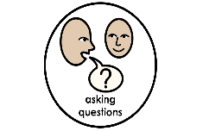
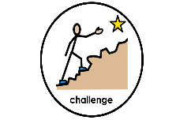
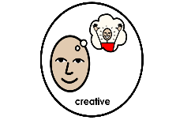
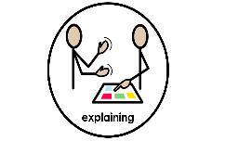
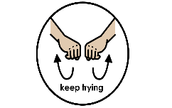
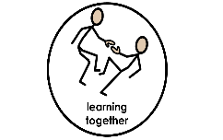
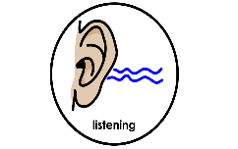
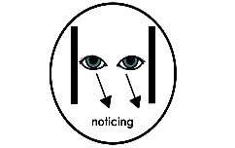
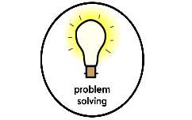
I can support my progress towards future independence through developing my Learning Habits. These are fundamental to how I can gain knowledge and grow my understanding, to use purposefully.

Numeracy  Cognition and Learning  Communication and Interaction | Literacy  Cognition and Learning  Communication and Interaction

I will learn and know how to use early Numeracy skills to support my growing confidence and independence.  LESSON BASED LEARNING  Teaching and learning focuses on the skills, knowledge, understanding and application of Number, Measurement, Geometry, Data collection and interpretation.  LEARNING CENTRES  Individual/pair/small group/whole class delivery of learning, following an active approach to maths teaching and learning, involving Numicon and practical and engaging resourcing and activity.  Cross curricular links – all areas  Classroom carpet area / zoned subject learning areas i.e. maths area  Classroom continuous provision / Courtyard - child initiated learning  Outdoor Classroom / School grounds  Cooking  Gardening  Shopping  Schedules / telling the time  Playground – marked out games  Trips and visits – application of learning in real life contexts  Games and play – language of maths  PE – following directions and positional language  D.T. – number, geometry and measurement  Daily classroom organisation – language of time  Role play | I will learn and know how to use early literacy skills to support my growing confidence and independence.  LESSON BASED LEARNING  Teaching and learning focuses on the skills, knowledge, understanding and application of Communication & Language, Reading, Phonics and Writing  LEARNING CENTRES  Individual/pair/small group/whole class group delivery of learning.  Small ability based phonics groups  Literacy and Speaking/Listening through drama  Shared guided reading  Social communication / role play scenarios  Cross curricular links – all areas  Classroom carpet area/zoned subject learning areas i.e. reading corner/writing area  Classroom continuous provision / Courtyard - child initiated learning  Outdoor Classroom / School grounds  Speaking in shared events – assemblies  Performance – in lessons and to wider audiences  Playground – communication and expression  Music – listening  Reading Focus Week – celebration of reading incl.  World Book Day  Range of resources for recording  Trips and visits – application of learning in real life contexts  Role play of real world contexts, imaginary play and games  School libraries  Colourful Semantics  Story telling / creating  Swimming – following instructions  Snack and lunch time  ‘Book for Home’ initiative
HOME LEARNING  Having pocket money, helping with the shopping, paying for things, reading the time, cooking at home, using language of comparison, tidying away and sorting, real life contexts for use of addition and subtraction. | HOME LEARNING  Daily reading at home, writing cards/postcards, sending emails and messages, speaking on the phone, creating shopping lists, holiday journals (written or filmed), reading language in the environment, chatting, small world play and role play.
Creative and Curious  Cognition and Learning  Sensory and Physical Needs  Communication and Interaction | Happy and Healthy  Communication and Interaction  Sensory and Physical Needs  Social, Emotional and Mental Health  Cognition and Learning
I can learn to be curious about the world around me and I am excited to find out.  LESSON BASED LEARNING  Creative and Curious cross-curricular learning includes Science, History, R.E., Geography, Art and D.T., Music, Drama and Computing. Teaching and learning focuses on developing skills, knowledge, understanding and application.  LEARNING CENTRES  Topic based, cross-curricular learning  Planned whole school ‘Focus’ weeks  Classroom continuous provision / Courtyard - child initiated learning  Drama and performance  Visits and trips out of school  Investigations  Immersive learning  Learning Outdoors - Outdoor Classroom / School grounds  Forest School  Allotment – growing, preparing, eating  Art and Design  Gosfest – whole school festival  Ukelele /music / singing  Research – online and libraries  IWB, ipad, online learning  HOME LEARNING  Home investigations and experiments  Building dens and treehouses  Gardening  Observing life cycles  Stories about the past  Visits to interesting places  Use of ICT in the home | I will learn how I can have a healthy mind and a healthy body.  LESSON BASED LEARNING  Happy and Healthy cross-curricular learning includes Physical development, PSHE, E-Safety, Social Communication skills, Gosden Values. Teaching and learning focuses on developing skills, knowledge, understanding and application.  LEARNING CENTRES  Timetabled Physical Education  Physical enrichment opportunities - judo, yoga, weekly access to external professionals  Off-site swimming lessons  Playground – organised games and activities  Morning playground dance  Cooking – healthy eating  Physio and O.T. support in class  Sponsored walks  KS4 Sports Leader led enrichment  Sports Day  Outdoor learning  Social communication sessions / role play scenarios  Celebration assemblies, dept. and whole school  Organised awareness days –Online safety  Gosden Pride  Dance and Art therapy  Timetabled PSHE/RSE – well-being, relationships, puberty and sex education  Use of Zones of Regulation – self regulation  Whole school ethos and trauma-informed approach to relational support  School Council representatives  Whole school community activities – Focus Week  Residential opportunity  HOME LEARNING  Contributing to the home (jobs/responsibilities)  Visits  Access to outdoors  Encouraging healthy eating / cooking  Access to community  Online learning  Online safety
ASSESSMENT
Baseline on entry
IEP targets / classroom targets
Evisense
In-house, collaborative moderation model
Tracking and monitoring development of Learning Habits
Pupil self-assessment and peer assessment/feedback
B-Squared used for recording attainment progress throughout Gosden experience
Subjects tracked on B-Squared and data reported on: Maths, English, PSHE

Updated JC November 2022

