Gosden House School PSHE Coverage
Guided by the national curriculum including the EYFS, the PSHE association and linking to bsquared – see separate LTP for RSE
PSHE Overview - Primary
Detailing topic coverage
Year Group | Autumn 1 | Autumn 2 | Spring 1 | Spring 2 | Summer 1 | Summer 2
Reception  EYFS categories | Self Confidence and Self-Awareness | Life skills  &  Self-Care | Managing Feelings and Behaviour | RSE – on other plan | RSE – on other plan | Making Relationships
Y1  EYFS categories | Self Confidence and Self-Awareness | Life skills  &  Self-Care | Managing Feelings and Behaviour | RSE – on other plan | RSE – on other plan | Making Relationships
Y2 | My World and the Wider World | Me and My Relationships | Health Lifestyle and Wellbeing | RSE – on other plan | RSE – on other plan | Life skills  &  Self-Care
Y3 | Life skills  &  Self-Care | My World and the Wider World | Me and My Relationships | RSE – on other plan | RSE – on other plan | Health Lifestyle and Wellbeing
Y4 | Life skills  &  Self-Care | My World and the Wider World | Me and My Relationships | RSE – on other plan | RSE – on other plan | Health Lifestyle and Wellbeing
Y5 | Health Lifestyle and Wellbeing | Me and my relationships | My World and the Wider World | Relationships and Sex Education – see separate plan | Relationships and Sex Education – see separate plan | Life skills  &  Self-Care
Y6 | Health Lifestyle and Wellbeing | Me and my relationships | My World and the Wider World | Relationships and Sex Education – see separate plan | Relationships and Sex Education – see separate plan | Life skills  &  Self-Care
PSHE Overview – Secondary
Detailing topic coverage
Year Group | Autumn 1 | Autumn 2 | Spring 1 | Spring 2 | Summer 1 | Summer 2
Y7 | My world & the wider world | Me and my relationships | Health lifestyle and wellbeing | Relationships and Sex Education – see separate plan | Relationships and Sex Education – see separate plan | Life skills
Y8 | My world & the wider world | Me and my relationships | Health lifestyle and wellbeing | Relationships and Sex Education – see separate plan | Relationships and Sex Education – see separate plan | Life skills
Y9 | Me and my relationships | Life skills | My world & the wider world | Relationships and Sex Education – see separate plan | Relationships and Sex Education – see separate plan | Health lifestyle and wellbeing
Y10 | My world & the wider world | Me and my relationships | Health lifestyle and wellbeing | Relationships and Sex Education – see separate plan | Relationships and Sex Education – see separate plan | Life skills
Y11 | Me and my relationships | Health lifestyle and wellbeing | My world & the wider world | Relationships and Sex Education – see separate plan | Relationships and Sex Education – see separate plan | Life skills

Teaching ideas and resources are initial things to get you started please take this in your own direction and share any amazing resources you find
EY  Categories from ELG & P levels | Self Confidence and Self Awareness | Managing Feelings and Behaviour | Making Relationships | Self-Care | Life Skills
Learning Objectives | To be willing to try new activities  To express why they like some activities more than others with support  To be confident communicating with a familiar adult  To share their ideas  To express when they do or do not need help | To begin to recognise some feelings i.e. happy and sad  To listen to others  To answer questions  To encourage a sense of being unique | To encourage joint activities  To understand sharing and to share resources willingly | To begin to indicate a need for the toilet (not always on time)  To use the toilet when prompted to or put on the toilet  To undress themselves with some support | To start to ask for an object they would prefer i.e. at snack time  To explore different scenarios through role play r.e. playing shops and cafes with some direction  To begin exploring cooking and baking with support  First Aid –  I know what first aid is  I know how to call for help if someone is hurt  I know the recovery position
Teaching ideas and useful resources | Create all about me books  Celebrating uniqueness; self-portrait, fingerprints express through art  The rainbow fish book  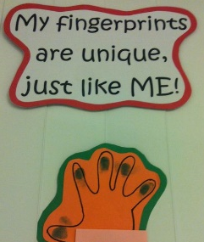 | Emotions dice  Thinking and feeling station  www.notimeforflashcards.com  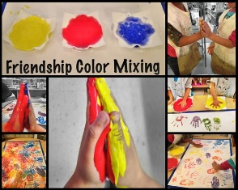  good website for circle time ideas and inspiration | Recipe for a good friend  http://preschoolpowolpackets.blogspot.com  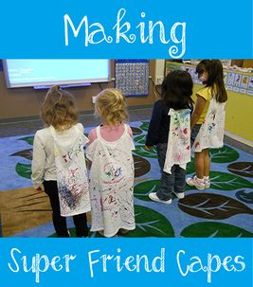  good website for sensory ideas for circle time/PSHE relating to friendships | Role play and dress up to explore dressing skills independently  Share books around toileting  Prompt cards where needed | www.allisonfors.com  good blog with speech and language games that can be adapted  www.fiveminutemum.com good speech and language and curriculum based games (lots of phonics too)
Year 1  Categories from ELG & P levels | Self Confidence and Self Awareness | Managing Feelings and Behaviour | Making Relationships | Self-Care | Life Skills
Learning Objectives | To be willing to try new activities  To express why they like some activities more than others independently  To be confident communicating within a familiar group  To share their ideas  To choose resources they need for their activities independently | To recognise some feelings i.e. happy and sad  To begin to express when they are feeling sad or happy with support | To encourage joint activities and teamwork in play  To give opportunities to explore co-operative play  To understand sharing and to share resources willingly | To indicate a need for the toilet (not always on time)  Gross Motor – To run steadily  To improve balancing skills  Fine Motor – To hold a pencil using a dagger drip  To hold a pencil using a pincer grip | To be able to ask for an object they would prefer i.e. at snack time  To explore different scenarios through role play r.e. playing shops and cafes  To begin learning to follow a recipe  First Aid –  I know what first aid is  I know how to call for help if someone is hurt  I know the recovery position
Teaching ideas and useful resources | Communication games and taking turns  Songs with parts and taking turns  https://famly.co/blog/inspiration/10-simple-communication-and-language-activities/  Pom Pom avalanche, Memory game, DIY telephone  Dance Freeze | 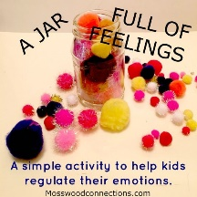  Books  Circle time – use P4C questions to open up | 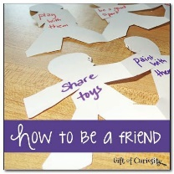  friendship charter | Role play and dress up to explore dressing skills independently  Share books around toileting  Prompt cards where needed | Trip to post office or links to topic – give a reason for the skills
Year 2  Categories from NC and P levels | Health Lifestyle and Wellbeing | My World and the Wider World | Me and My Relationships | Self-Care | Life Skills
Learning Objectives | To put resources away in the correct places  To feed themselves  To take off and put on coat, hat and gloves independently  To explore different kinds of food | To share objects when prompted  To play with a range of objects  To select own materials to use  To begin to problem, solve | To greet people by name  To communicate with others enthusiastically  To explore what it means to be a good friend | To begin to dress independently  To undress independently  Put resources away independently | To begin to use money to work out how to pay for items  To follow a recipe with support  To sequence a recipe with support  First Aid –  I know what first aid is  I know how to call for help if someone is hurt  I know the recovery position  I know when to call 999  I know how to call 999
Teaching ideas and useful resources | http://intheplayroom.co.uk/2016/02/26/fun-activities-to-encourage-healthy-eating/  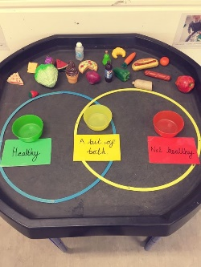  Healthy eating games | https://www.firstdiscoverers.co.uk/encourage-sharing-early-years/  blog with games to encourage sharing  https://nrich.maths.org/13371  problem solving games and ideas | Hello and goodbye songs, speaking and listening games. Small group work – play games to take turns  Friendship charter and display | Dressing cards  Sequencing together | 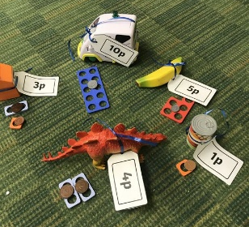
Year 3  Categories from NC and P levels | Health Lifestyle and Wellbeing | My World and the Wider World | Me and My Relationships | Self-Care | Life Skills
Learning Objectives | Begins to express likes and dislikes clearly  Begins to verbalise feelings with support; happy, angry, love, scared and sad  To get an apron when painting (and other relevant tools) independently | To explore helping others  Shows an awareness of danger – To be able to cross the road safely  To work independently at times  To share their own ideas and respond to other’s ideas | To work alongside a peer without the help from any adults  To begin to learn an awareness of the feelings of others  To co – operate with peers in a led task  To understand when to regulate i.e. to remove themselves from a situation when needed | To dress and undress independently  To use the toilet independently  To look after resources carefully  To learn to tie shoes | To follow a recipe independently  To sequence a recipe independently  To be able to buy an item at a shop (role play or trip)  To post a postcard or letter with support  First Aid –  I know what first aid is  I know how to call for help if someone is hurt  I know the recovery position  I know when to call 999  I know how to treat some simple ailments i.e. nose bleed, cut knee
Teaching ideas and useful resources | https://www.giftofcuriosity.com  games for exploring feelings  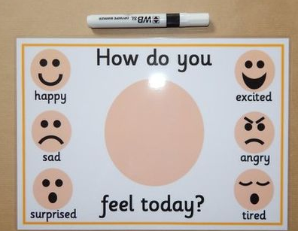 | 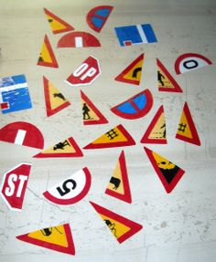  Road safety role play  Recognising signs  Road safety song | 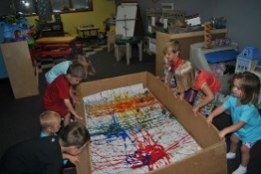  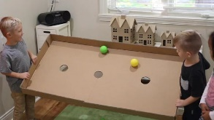  Teamwork games – parachute games, problem games and turn taking. | Sequence changing  Use symbol matching for  resources | Role play, trips, writing a letter to themselves (posted to home address) or a pen pal.
Year 4  Categories from NC and P levels | Health Lifestyle and Wellbeing | My World and the Wider World | Me and My Relationships | Self-Care | Life Skills
Learning Objectives | To express likes and dislikes clearly  To verbalise feelings with support; happy, angry, love, scared and sad with support  To get an apron when painting (and other relevant tools) independently | To learn the number of their house and the name of their street (to learn where their house is and what an address is)  To identify the month, they are born in  To begin to show some awareness of the feelings of others | To share equipment willingly and interact with their peers when doing so  To take turns in group games  To begin to demonstrate an awareness that not everyone feels the way they do  To accept that they can not always do what they want to | To use appropriate language to ask for the toilet  To ask for help with toileting if required  To go to the toilet independently  To try to tear paper in half  To begin to copy folding skills  To jump over objects  To climb with confidence | To follow a recipe independently  To be able to make a sandwich independently  To post a letter  To buy an item at the shop with support  First Aid –  I know what first aid is  I know how to call for help if someone is hurt  I know the recovery position  I know when to call 999  I know how to assess for danger in an emergency situation (i.e. do not run into road to help someone)  I know where the first aid kit is in school  I know how I might treat some common ailments with adult support i.e cut knee, nosebleed
Teaching ideas and useful resources | https://www.bbc.com/bitesize/clips/zk2w2hv  https://www.bbc.co.uk/cbeebies/shows/feeling-better  videos exploring emotions and feeling better | http://lastingthumbprints.com/8-ways-to-teach-children-their-address-and-phone-number/#_a5y_p=1471327  ideas of how to learn address and phone number; maps, songs and games | http://www.earlyyearscareers.com/eyc/learning-and-development/7-great-ways-to-encourage-turn-taking/  Turn taking game ideas – sharing bins, special items etc  Bucket therapy – sharing focus | Origami games  Opportunities to climb  Toilet cards and symbols to support asking | Robot sandwich instructions – program your teacher to make a jam sandwich https://www.youtube.com/watch?v=leBEFaVHllE
Year 5  Categories from NC and P levels | Health Lifestyle and Wellbeing | My World and the Wider World | Me and My Relationships | Self-Care | Life Skills
Learning Objectives | To express likes and dislikes clearly  To verbalise feelings with support; happy, angry, love, scared and sad independently  To get an apron when painting (and other relevant tools) independently  To express their feelings through creative work | To show some awareness of the feelings of others  Begin to understand changes in routine  To begin to explore that others’ have different ideas and these are not wrong  To discuss ideas with a partner | To engage with others in a group spontaneously  To show consideration towards others  To co-operate with a peer using one piece of equipment  To develop relationships so that they can get on well with peers with no adult present  To begin to help a peer with a task they find difficult | To use appropriate language to ask for the toilet  To use the toilet independently  To begin to throw ball overhead  To throw objects in the intended direction  To catch a large ball with support | To follow a recipe independently  To be able to make a simple meal independently  To post a letter  To buy an item at the shop independently  To know how to make a phone call with support  To learn about calling the emergency services responsibly  First Aid –  I know what first aid is  I know how to call for help if someone is hurt  I know the recovery position  I know when to call 999  I know how to assess for danger in an emergency situation (i.e. do not run into road to help someone)  I know where the first aid kit is in school  I know how I might treat some common ailments with adult support i.e cut knee, nosebleed
Teaching ideas and useful resources | 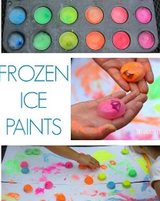  https://www.artsy.net/article/artsy-editorial-art-feeds-teaching-children-express-emotions-artmaking interesting read and some ideas about art therapy initiative  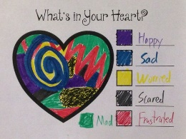 | https://www.teachingideas.co.uk/subjects/pshe  ideas by subject i.e. sharing  sharing a shell – Julia Donaldson | https://www.everyschool.co.uk/pshe-foundation-caring-for-others.html  Videos and prompts for helping others | Gross motor exercises – balls, OT room and throwing skills  Indoor movement games - Bean bags in baskets, paper plate pathways, play find and tag, move like an animal and balloon game. | http://kids.triplezero.gov.au/Teachers_Guide.pdf  ideas for calling emergency services etc.
Year 6  Categories from NC and P levels | Health Lifestyle and Wellbeing | My World and the Wider World | Me and My Relationships | Self-Care | Life Skills
Learning Objectives | To express their feelings through creative work  To begin to communicate their fears  To listen to and begin to understand why actions may be wrong or right  To communicate how a story or poem makes them feel | To show awareness of the feelings of others  To begin to explore how their actions affect the feelings of others  To accept some changes in routine  To begin to understand that not everyone thinks the same way they do  To initiate an activity of their choice | To co – operate with a peer to complete a task  To share an adult with 10 others/within a group  To develop relationships so that they can get on well with peers with no adult present  To help a peer with a task they find difficult with no prompting | To use appropriate language to ask for the toilet  To use the toilet independently  To throw ball overhead  To catch a large ball independently  To show an awareness of the movement and direction of others | To follow a recipe independently  To be able to make a simple meal independently  To write and post a letter  To buy an item at the shop independently  To know how to make a phone call independently  To learn about calling the emergency services responsibly  First Aid –  I know what first aid is  I know how to call for help if someone is hurt  I know the recovery position  I know when to call 999  I know how to assess for danger in an emergency situation (i.e. do not run into road to help someone)  I know where the first aid kit is in school  I know how I might treat some common ailments with adult support i.e cut knee, nosebleed
Teaching ideas and useful resources | The dark – by Lemony Snickett (Lazlo)  Emily Gravett – Big Book of Fears  Add a page to big book of fears  Listen to a range of stories and poems | Reading social stories together – change in routine  Give them the ownership over the social stories  Feelings wheel  Choosing from a few options | https://www.everyschool.co.uk/pshe-foundation-caring-for-others.html  Videos and prompts for helping others | Indoor movement games - Bean bags in baskets, paper plate pathways, play find and tag, move like an animal and balloon game  Awareness of others movements - obstacle course, mirror game etc. | http://kids.triplezero.gov.au/Teachers_Guide.pdf  ideas for calling emergency services etc.

Teaching ideas and resources are initial things to get you started please take this in your own direction and share any amazing resources you find
Year 7  Categories from NC and bsquared levels | Health Lifestyle and Wellbeing | My World and the Wider World | Me and My Relationships | Life Skills
Learning Objectives | I can name different kinds of diets i.e vegetarian  I know how germs can be passed along  I know why I need to wash my hands  I know that medicine can help cure some illnesses  I know some ways I can feel calm  I know what metal health is  I know my mental health is as important as my physical health  I know some ways to care for my mental health | I know what a community is  I can name some examples of a community  I understand the benefits of a specific community  I can reflect on a task I have achieved  I can give an example of a task I have achieved | I know what a role model is  I understand there can be good and bad role models  I can categorise characters into good or bad role model  I can work in a team with a range of peers | I know how to ask for help if I have a problem online  I can make a snack for myself or others  I can make a hot drink independently  I can write a simple shopping list
Teaching ideas and useful resources | Wash your hands - https://www.youtube.com/watch?v=48etEql31D4  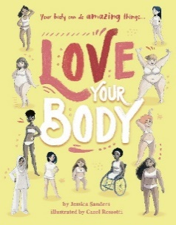 | 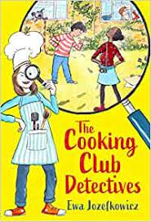  story about community | Celebrity role models  Use characters from your current class story to categorise  Team building games – bridge with spaghetti etc. | Research snacks and plan  First Aid –  I know what first aid is  I know how to call for help if someone is hurt  I know the recovery position  I know when to call 999  I know how to assess for danger in an emergency situation (i.e. do not run into road to help someone)  I know where the first aid kit is in school  I know how I might treat some different injuries i.e. head injury, cut or burn  I know how to get first aid help safely when I am out and about
Year 8  Categories from NC and bsquared levels | Health Lifestyle and Wellbeing | My World and the Wider World | Me and My Relationships | Life Skills
Learning Objectives | I can name different kinds of diets i.e vegetarian  I know how germs can be passed along  I know why I need to wash my hands  I know that medicine can help cure some illnesses  I understand what a mistake is  I know that a mistake is a good thing (it is how I learn)  I can celebrate a mistake I have made with support  I can say something I am good at  I know some activities I can do to make me feel calm  I know what metal health is  I know my mental health is as important as my physical health  I know some ways to care for my mental health | I know what a community is  I can name some examples of a community  I understand the benefits of a specific community  I can reflect on a task I have achieved  I can give an example of a task I have achieved | I can ask for help to solve a disagreement  I can think of some ways to solve a specific disagreement with support  I know what a role model is  I understand there can be good and bad role models  I can categorise characters into good or bad role model  I can work in a team with a range of peers | I know how to ask for help if I have a problem online  I can make a snack for myself or others  I can make a hot drink independently  I can write a simple shopping list  I can call the emergency services independently  First Aid –  I know what first aid is  I know how to call for help if someone is hurt  I know the recovery position  I know when to call 999  I know how to assess for danger in an emergency situation (i.e. do not run into road to help someone)  I know where the first aid kit is in school  I know how I might treat some different injuries i.e. head injury, cut or burn  I know how to get first aid help safely when I am out and about
Teaching ideas and useful resources | Make a growth mindset playlist of songs to celebrate mistakes and have a boogie here is one to start you off - https://www.youtube.com/watch?v=c6rP-YP4c5I | Make a reflection log | book about friends who disagree | 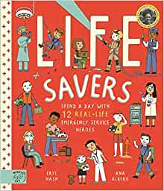
Year 9  Categories from NC and bsquared levels | Health Lifestyle and Wellbeing | My World and the Wider World | Me and My Relationships | Life Skills
Learning Objectives | I can sequence a familiar routine  I can plan my bedtime routine with support  I can plan my morning routine with support  I know that there are no ‘good’ or ‘bad’ foods (all food gives you energy and is OK in balance)  I know that food gives me energy  I know that my body is not the most important part of me  I know what mindfulness is  I know some ways I can feel mindful  I know what metal health is  I know my mental health is as important as my physical health  I know some ways to care for my mental health | I can name some local communities  I can think of a community I would like to join  I can celebrate my own mistake  I know that I can keep trying when I make a mistake  I can plan again when I have made a mistake (task orientated) | I know what bullying is  I know that is wrong to bully someone  I know how to ask for help if I am being bullied  I know how to be kind to others  I know what racism is  I know it is wrong to treat people differently because of the colour of their skin | I know how to ask for help if something online worries me  I know what personal hygiene is  I know how to use deodorant  I know when I need to wash myself  I can make a hot drink independently  First Aid –  I know what first aid is  I know how to call for help if someone is hurt  I know the recovery position  I know when to call 999  I know how to assess for danger in an emergency situation (i.e. do not run into road to help someone)  I know where the first aid kit is in school  I know how I might treat some different injuries i.e. head injury, cut or burn  I know how to get first aid help safely when I am out and about  I know how to respond in some emergency situations i.e. choking, allergic reaction, asthma attack
Teaching ideas and useful resources | Create routine chart  Make a video teaching others your routines  Mirror talk as a class  Daily affirmations as a class – write your own affirmations | Create a growth mindset booklist as a class or area in your class book case | 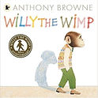  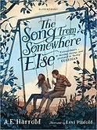 | Make a personal hygiene plan  Make a keep clean kit of things to help with personal hygiene
Year 10  Categories from NC and bsquared levels | Health Lifestyle and Wellbeing | My World and the Wider World | Me and My Relationships | Life Skills
Learning Objectives | I know that cigarettes are harmful  I can sequence a familiar routine  I can plan my bedtime routine with support  I can plan my morning routine with support  I know that there are no ‘good’ or ‘bad’ foods (all food gives you energy and is OK in balance)  I know that food gives me energy  I know that my body is not the most important part of me  I can say something I like about myself  I have a bank of tools to feel calm  I know what metal health is  I know my mental health is as important as my physical health  I know some ways to care for my mental health | I can use my previous knowledge to problem solve  I know how to join a club | I know what racism is  I know it is wrong to treat people differently because of the colour of their skin  I know what sexism is  I know what feminism is  I know that it is wrong to treat people differently because of their gender | I know how to set privacy settings online  I know how to not share my location online  I can plan my personal hygiene routines  I can make a meal independently  First Aid –  I know what first aid is  I know how to call for help if someone is hurt  I know the recovery position  I know when to call 999  I know how to assess for danger in an emergency situation (i.e. do not run into road to help someone)  I know where the first aid kit is in school  I know how I might treat some different injuries i.e. head injury, cut or burn  I know how to get first aid help safely when I am out and about  I know how to respond in some emergency situations i.e. choking, allergic reaction, asthma attack
Teaching ideas and useful resources | Create an individual calm box to remind them of tools | Practise researching clubs based on interests | 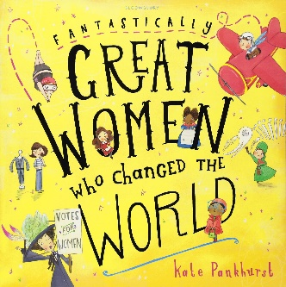 | Practise setting privacy settings on different apps using visuals – sequence
Year 11  Categories from NC and bsquared levels | Health Lifestyle and Wellbeing | My World and the Wider World | Me and My Relationships | Life Skills
Learning Objectives | I know that cigarettes are harmful  I know that drugs are harmful  I know what peer pressure is  I know how to ask for help if someone is pressuring me to smoke or do drugs  I know that there are no ‘good’ or ‘bad’ foods (all food gives you energy and is OK in balance)  I know that food gives me energy  I know that my body is not the most important part of me  I can say something I like about myself  I have a bank of tools I can use to feel calm  I know what metal health is  I know my mental health is as important as my physical health  I know some ways to care for my mental health | I can use my previous knowledge to problem solve  I know how to join clubs once I have left school | I know what racism is  I know it is wrong to treat people differently because of the colour of their skin  I know what sexism is  I know what feminism is  I know that it is wrong to treat people differently because of their gender  I know when a situation feels right or wrong  I know what a red flag is  I can identify a red flag in a situation | I know how to make a drs appointment for myself  I know what I need to go to the dr for and what I need to go to a&e for  I can plan a week of meals  I can use a budget for a weekly shop  I can make a few meals independently  First Aid –  I know what first aid is  I know how to call for help if someone is hurt  I know the recovery position  I know when to call 999  I know how to assess for danger in an emergency situation (i.e. do not run into road to help someone)  I know where the first aid kit is in school  I know how I might treat some different injuries i.e. head injury, cut or burn  I know how to get first aid help safely when I am out and about  I know how to respond in some emergency situations i.e. choking, allergic reaction, asthma attack
Teaching ideas and useful resources | What I like about me portrait  Meditation for kids  https://www.youtube.com/c/CosmicKidsYoga  cosmic kids yoga | Research clubs and how to join  Role play scenarios | https://www.booksfortopics.com/upper-ks2-diverse-and-inclusive  https://www.booksfortopics.com/bame-characters  https://www.booksfortopics.com/black-lives-matter  https://www.blacklivesmatteratschool.com/ | Meal plan template

