GOSDEN HOUSE SCHOOL ACCESSIBILITY PLAN
Gosden House School recognizes and values the contributions that parents, carers, governors, and other members of the community can make. We will endeavour to encourage the wider community to understand the aims and vision of the school and to involve them wherever possible.

Provision of information in other formats - We will endeavour, wherever possible, to provide information in alternative formats when required or requested. Examples of this are by using email, royal mail, enlarged print versions, audio tapes, translations, and symbolled text. Adequate prior notice would be required through the school office.

Accessibility to premises - To continue to ensure that the school building and grounds are accessible to the extended school community, pupils, staff, governors, parents, and community members as far as reasonably possible.

Gosden House School -

Medical Policy

Date of the original policy | Jan 2014
Original school author | Davina Dunn
Review date and SLT initial | Max Valentino December 2022 updated January 2023
Next review date | December 2025
Date approved and signed in governing body meeting

CONTENTS
 | Page
School Ethos and Aims | 4
Unacceptable Practice | 5
Entitlement | 5
Expectations | 6
Information | 6
In an emergency | 7
Medication Journey | 7
Safe Disposal of Medicines | 8
Storage of Medication | 8
Administration of Medication including Controlled Drugs | 9
Forms | 10
Epilepsy | 11
Asthma | 11
Allergies and Anaphylactic Shock | 12
Homely Remedies (non-prescribed medication) | 13
Automated External Defibrillators - AED | 14
Recording an injury | 15
Medical Absences | 15
Training | 15
Medical Errors and ‘near misses’ | 16
Complaints | 16
The Medical Team | 17
Trained First Aiders | 17

APPENDICES
 | Page
Appendix 1 – Medication Administration Record (MAR) | 18
Appendix 2 – Pupil Medication Request | 19
Appendix 3 - Parent Permission Sheet for Non-Prescribed Medication & Home Medication Information | 20
Appendix 4 – Non-prescribed Medication Class Record | 21
Appendix 5 – Staff Trained in administering Buccal Midazolam | 22
Appendix 6 – Staff trained in Asthma & Anaphylactic Shock | 23
Appendix 7 – Consent for Emergency Salbultamol Inhaler Use | 24
Appendix 8 – What to do in the event of an asthma attack | 25
Appendix 9– How to recognise an asthma attack | 26
Appendix 10 – Example of how to administer an auto-injector | 27
Appendix 11 – Medication Incident Record | 28
Appendix 12 – Medical team of responsibilities | 29
Appendix 13 – Contact List | 30
Appendix 14 – Staff trained in Medicine Awareness – Course for Schools and Early Years (Foundation Level) | 31
Appendix 15 – Being returned home – Medication log in/log out Form | 32
Appendix 16 – Staff trained in St John’s First Aid at Work (one day) | 33
Appendix 17 - Resuscitation Action Plan – Automated External Defibrillator | 34
Appendix 18 – En-Plugs Training by Nutricia Home Ward Nursing Services Training | 35

Definition

Pupils’ medical needs may be broadly summarised as being of two types:
- Short-term, affecting their participation in school activities in which they are on a course of medication.
- Long-term, potentially limiting their access to education and requiring extra care and support

School Ethos

Schools have a responsibility for the health and safety of pupils in their care. The Health and Safety at Work Act 1974 makes employers responsible for the health and safety of employees and anyone else on the premises. In the case of pupils with special medical needs, the responsibility of the school is to make sure that safety measures cover the needs of all pupils at the school. This may mean making special arrangements for particular pupils so that they can access their full and equal entitlement to all aspects of the curriculum. In this case, individual procedures may be required. Gosden House School is responsible for making sure that relevant staff know about and are, if necessary, trained to provide any additional support that pupils with medical conditions (long or short term) might need.

The Children and Families Act 2014 places a duty on schools to arrange for children with medical conditions. Pupils with medical conditions have the same right to admission to school as other children and cannot be refused admission or excluded from school on medical grounds alone. However, teachers and other school staff in charge of pupils have a common law duty to act ‘in loco parentis’ and must ensure the safety of all pupils in their care. To this end, we reserve the right to refuse admittance to a child with an infectious disease, where there may be a risk posed to others or to the health of the child involved. This duty also extends to teachers leading activities taking place off the school site.

The prime responsibility for a child's health lies with the parent, who is responsible for the child's medication and must supply the school with all relevant information needed for proficient care to be given to the child. The school takes advice and guidance from a range of sources, including the School Nurse, Health professionals, and the child’s GP in addition to the information provided by parents in the first instance. This enables us to ensure we assess and manage risk and minimize disruption to the learning of the child and others who may be affected (for example, classmates).

Our Aims

- To support pupils with medical conditions, so that they have full access to education, including physical education and educational visits.
- To ensure that school staff involved in the care of children with medical needs are fully informed and adequately trained by a professional to administer support or prescribed medication.
- To comply fully with the Equality Act 2010 for pupils who may have disabilities or special educational needs.
- To write, in association with healthcare professionals, Individual Healthcare Plans where necessary.
- To respond sensitively, discreetly, and quickly to situations where a child with a medical condition requires support.
- To keep, monitor, and review appropriate records.

Unacceptable Practice

While school staff will use their professional discretion in supporting individual pupils, it is unacceptable to:
- Prevent children from accessing their medication.
- Assume every child with the same condition requires the same treatment.
- Ignore the views of the child or their parents/carers; ignore medical advice.
- Prevent children with medical conditions from accessing the full curriculum, unless specified in their Individual Healthcare plan.
- Penalise children for their attendance record where this is related to a medical condition.
- Prevent children from eating, drinking, or taking toilet breaks where this is part of the effective management of their condition.
- Require parents to administer medicine where this interrupts their working day.
- Require parents to accompany their child with a medical condition on a school trip as a condition of that child taking part.

Entitlement

Gosden House School provides full access to the curriculum for every child wherever possible. We believe that pupils with medical needs have equal entitlement and must receive necessary care and support so that they can take advantage of this. However, we also recognize that employees have rights concerning supporting pupils with medical needs, as follows:

Employees may:
- Choose whether or not they wish to be involved;
- Receive appropriate training;
- Work to clear guidelines;
- Bring to the attention of Senior Leadership any concern or matter relating to the support of pupils with medical conditions;

Expectations

It is expected that:
- Parents will inform the school of any medical condition, which affects their child.
- Parents will supply the school with appropriately prescribed medication, where the dosage information and regime are clearly printed by a pharmacy on the container.
- Parents will ensure that medicines to be given in school are in date and clearly labelled.
- Parents will cooperate in training their children to self-administer medicine if this is appropriate, and staff members will only be involved if this is not possible.
- Parents (and staff) will be aware of Surrey County Council policy concerning the incidence of sickness and/or diarrhoea – i.e. any incidence of either condition should be followed by 48 hours of absence from school from the last bout of sickness and/or diarrhoea.
- Medical professionals involved in the care of children with medical needs will fully inform staff beforehand of the child’s condition, its management, and implications for the school life of that individual.
- Staff will ensure that, where appropriate, children are involved in discussing the management and administration of their medicines and can access and administer their medicine if this is part of their Individual Healthcare plan (for example, an inhaler).
- School staff will liaise as necessary with Healthcare professionals and services to access the most up-to-date advice about a pupil’s medical needs and will seek support and training in the interests of the pupil.
- Transitional arrangements between schools will be completed in such a way that Gosden House School will ensure full disclosure of relevant medical information, Healthcare plans, and support needed in good time for the child’s receiving school to adequately prepare.
- Individual Healthcare plans will be written, monitored, and reviewed regularly and will include the views and wishes of the child and parent in addition to the advice of relevant medical professionals.
- It is the Medical Lead’s responsibility to ensure that all medical information is shared with the class team and office-based, named first aiders.

Information

There are two medical boards in the school; one is located in the admin office and one is outside the main kitchen. Displayed on these boards are photos and information about any children with serious medical conditions.

Health care plans of children on the Asthma register, Epilepsy register, and Diabetes register are displayed on these boards, alongside information on the children who take controlled drugs at school and have known allergies. The information is colour coded so it is easy and quick to access.
All medical conditions are shown on the children’s SIMs records and this information is shared with the class teacher and office-based, named first aiders. The class teacher also has a copy of the individual care plans of the children in their class.

It is the class teacher’s responsibility to ensure that the class team is aware of the medical needs of the class and that they know where a copy of the SIMs record sheet and any individual health care plans are stored.

It is the class teacher’s responsibility to ensure that a copy of the SIMS record sheet and individual health care plans are stored in the class file and that this is easily accessible at all times.

We can refer to the British National Formulary for Children (BNFC) website should we require any key information on administration of medicines used for children. https://bnfc.nice.org.uk.

Asthma, Anaphylaxis, and Epilepsy training power points are stored on staff share 2022 – 2023. Medical Guidance.

In an emergency

In a medical emergency, a named first aider should be called.

If an ambulance is needed, the member of staff calling the ambulance will:

- Give an outline of the reason for the call and how, if it is an injury, it occurred
- Give details of the child’s date of birth, address, parent's name,
- Share other medical information, including any medication details, shown on the class overview sheet and/or healthcare plan.

A member of staff can accompany the child to the hospital if this is deemed appropriate.

Parents will be called/notified, of a medical emergency; however, they do not need to be present for a child to be taken to the hospital.

Medication Journey

All medication should be handed to a member of SLT on arrival to school by the parent, escort, or driver.

The medication is then handed to a member of the class team, who will store it in the medical cabinet or medical fridge.

Each class has a ‘being returned home ‘log-out/log-in form, which is kept in the medicine cabinet – refer to Appendix 15. A member of the class team will hand any medication being returned home to the parent, escort, or driver at the end of the school day. Medication being returned home will be logged out on this sheet.

Any medication leaving site during the school day will be recorded on the school log-out/ log-in sheet. This information will also be detailed on the ‘off-site’ visit sheet. The school log-out/ log in sheet is kept in the medical cabinet in the admin office.

Safe disposal of Medicines

Any medication that has expired will be returned to the parents.

If a child has left school or the school is unable to return the parents, then the medical lead will dispose of the medication at the local link pharmacy (Wonersh).

Any medication returned to parents will be recorded on CPOMS under the medical tab. The recorder will identify the name of the medication, the expiry date, and the amount or the number of tablets returned.

Any sharps or needles will be disposed of in the sharps bin kept in the medical cabinet in the main office.

Storage of medication

Every class has a lockable medical cabinet and secure key safe. The code for the key safe is stored in the main office hub and is known by the class team. The medical cabinet only stores medication for that class or tutor group.

It is the class teacher’s responsibility to ensure that the names of the students that cannot have pain relief or antihistamine is clearly shown on the inside of the class’s medicine cabinet.

The C02 electronic devices in each class will be located close to the medical cabinets and the class team will monitor the room temperature to ensure that the temperature in the cabinets does not rise above 25 degrees Celsius. 25 degree Celsius or below is the recommended temperature to store medication safely.

Medication that requires refrigeration will be stored in a lockable container in a fridge. The temperature of the fridge holding the medication will be between 2–8 degree Celsius. The temperature of the fridge will be checked daily.

It is the person administering the medication's responsibility to check that the medication is in date. Any Medication that is out of date will be returned to the parents or local pharmacy.

All medicines, including controlled medication, pain relief, and antihistamines, will be stored safely in the class medicine cabinet. Any controlled drugs will be stored on the top shelf of the cabinet. No other medication will be stored on this shelf.

All medication must be in its original container and be clearly labelled. For prescription medication, the label must have been printed by the dispensing pharmacy with the medication's name, child's name and details, GP's name, date of issue, dosage and instructions, and expiry date. Any controlled drugs will have a POM and CD logo on the packet.

Access to the controlled medication is restricted to the class team or members of the Senior Leadership Team.

Administration of Medication including Controlled Drugs

Parents must complete a permission slip before medication can be administered at school. If medication is sent into school without the permission form signed, a member of staff will call the parent/ carer to seek verbal consent. That member of staff will complete the information required on the permission slip and agree with the parent, that on this occasion only, the medication with be administered at school. The permission slip will be sent home that evening for the parent/ carer to sign and return the next day.

For prescription medication, the label must have been printed by the dispensing pharmacy with the medication's name, child's name and details, GP's name, date of issue, dosage and instructions, and expiry date.

Other medications must be in their original container and date.

The opening date for medications with a shorter life span, such as eye drops, creams, and some liquids must be shown on the medication-recording sheet.

Medication will be administered on Educational Visits, subject to the conditions above, and be included in the risk assessment. Staff supervising the visit will be responsible for safe storage and administering the medication during the visit.

Before administering any medication, the two members of staff will use the six R’s checklist, recommended by Nice. They will check that the medication is for the right person, it is the right medicine, it is being administered via the right route, and they are giving the right dose, at the right time, whilst remembering that the child has a right to refuse.

Only school-trained staff will administer the medication, any member of staff can witness the medicine being given unless it is classified as a controlled drug, in which case, both the administrator and the witness, must have completed the Medicine Awareness Course.

All controlled drugs will have a POM and CD logo on the packet.

Immediately after giving the medication, the staff administering the medication will return it to the top shelf of the medication cabinet and put the key back in the key safe.

Parents will be notified of any ill effects that the child may have after taking the medication. Any side effects observed will also be recorded on the MAR.

Refer to Appendix 14 for a list of staff that have completed the Medicines Awareness Course for Schools and Early Years (Foundation Level)

Forms

We use a standardised Medical Administration Record form (MAR) to record any medication given at school – refer to Appendix 1. The two staff members administering the medication must countersign this form. At the end of each term, the MARs will be scanned and uploaded onto CPOMS.

The staff signature log is kept in the medicine cabinet. The staff signature log is a list of all staff, their signature, and initials, who can administer or witness medication being given.

Staff will use both initials when signing against a MAR.

For ‘short term’ medications such as antibiotics, a photocopy of the MAR will be returned with the medication, to the parent/ carer each day and the class ‘Being Returned Home log-out and log-in’ sheet will be completed. Refer Appendix 15.

Any child refusing to take the medication in school will not be made to do so, parents will be informed about the dose being missed, and it will be recorded on the medication-recording sheet as refused.

If medicine given is spat out, parents will be informed and it will be recorded on the MAR as spat out. Another dose will not be given. If the medicine is in tablet form, the tablet will be put in a named envelope, stored in the locked medicine cabinet, and returned to the parent in person, or via the escort or driver at the end of the school day.

The school will not administer any medication covertly unless they are in the young person’s best interest and a lack of capacity has been assessed by Gillick competence.

Parents are required to complete a Pupil Medication Request form for any medication to be administered at school – refer to Appendix 2.

Parents are required to complete a parent permission sheet for us to administer non-prescribed medication – refer to Appendix 3. Staff will keep a record of any non-prescribed medication given on the Non-prescribed Medication Record sheet – see Appendix 4.

Epilepsy

Children with epilepsy are identified on the medical boards and each has an individual health care plan. This information is shared with the class teacher and office-based, named first aiders.

It is the class teacher’s responsibility to ensure that this information has been shared with the class team and that the individual health care plan is stored in the class file.

See Appendix 5 for a list of staff that has received the Epilepsy Buccal Midazolam training and can administer this drug.

In the event of a seizure, guidance shown on the individual health care plans will be followed.
For those students with a generic plan, the SIMS data sheet is attached.

Asthma:

All children that have been diagnosed with Asthma will have an individual asthma plan in place.

The asthma plan will be shared with the class team, office-based, named first aiders, and copies will be available on the main office medical board and main kitchen board.

Emergency salbutamol inhalers and spacers are stored in the medical cabinet in the main office and the first aid bags in the mini-buses.

Children, for whom written parental consent has been given, or directed by emergency services, will only use the emergency salbutamol inhalers and spacers. If an emergency salbutamol inhaler has been used, the parents will be informed.

Guidance on what to do in the event of an asthma attack and how to recognize an asthma attack is displayed on the medical boards and in each class’s medical cabinet – refer to Appendices 8 & 9.

The office-based, named first aiders or staff members that have received Asthma training, can be called to assist and administer an emergency inhaler, as well collecting the emergency inhaler and spacers from the medical cabinet. Before administering, they will check that parental consent is in place – refer to Appendix 7.

Children diagnosed with asthma should have their own reliever inhaler at school to treat symptoms and for use in the event of an asthma attack.

Children that can self-administer their inhalers themselves will be encouraged to do so and a risk assessment will be completed.
The class teacher is responsible for checking that the inhaler is named and accessible to that child at all times.

All children with an inhaler must take them out to PE and on any educational visits, however short the duration.

Usage of the inhalers will be recorded on the MAR. Staff will notify parents, and record on CPOMS, any changes that are different to symptoms/ dosage advised on the asthma plan.

The class team is responsible for notifying parents if the expiry date has been reached. Asthma inhalers that are out of date or empty will be returned to parents, or our local, link chemist – Wonersh Surgery.

In the event of a child having an asthma attack, guidance shown on their asthma plan will be followed.

See Appendix 6 for the members of staff who have received Asthma and anaphylactic shock training.

Allergies and anaphylactic shock:

Pupils with allergies are identified on the medical boards, information is shared with the class teacher, and office-based named first aiders.

Any child with a prescribed auto-injector will have an individual health care plan.

The individual health care plan will be shared with the class teacher, office-based, named first aiders, and displayed on the medical boards.

Guidance on how to administer an auto-injector has been shared with all classes and is displayed on the medical boards and next to class medical cabinets refer to appendix 10.

It is the class team’s responsibility to ensure that the auto-injectors are easily accessible at all times, including outside or other areas of the school. The auto-injectors can be carried in a bag by the pupil or accompanying adult.

Auto-injectors are not to be stored in locked cupboards. At Gosden House School, unless the medicine cabinet is in direct sunlight, the auto-injector will be stored on top of the class medical cabinet, always out of reach of the pupils and never in the fridge.

The emergency auto-injector is stored in the medical cabinet in the main admin office. This can only be administered to the pupils that we have parental consent for or if medical staff following a 111 or 999 call have advised us.

Any member of staff can administer an auto-injector in an emergency to a child with a prescribed auto-injector or advised by the medical staff 111 or 999.

It is the medical lead's responsibility to check that the emergency auto-injector date has not expired.

In the event of a child showing symptoms of an allergy or anaphylactic shock or an auto-injector is given, an ambulance will be called immediately. The child should be encouraged to sit down, stay sitting, and not stand up. Parents should be contacted after the ambulance has been called.

Homely Remedies (non-prescribed medication)

Only staff that have participated and passed the Medicines Awareness Course for Schools and Early Years (Foundation Level) will administer non-prescriptive medication, and only when they have written consent from the pupil’s parent or carer.

All non-prescribed medication will be recorded on a Non-Prescribed Medication Class Record (refer to appendix 4) details will be uploaded onto CPOMS, and parents will be informed via the home/school book, email or a telephone call.

Examples of non-prescribed, over-the-counter medicines are acetaminophen (pain relief), aspirin, antacids, decongestants, antihistamines, and laxatives.

Pain relief will not be administered before noon, without seeking consent from the parent/ carer first.

It is the parents/ carer’s responsibility to ensure that any non-prescribed medication sent to school, does not influence or affect other medication the child may be taking.

It is the parent's/ carers duty to inform the school if a child suffers any adverse effect from any medication given.

Aspirin will not be given to any child under 16 years old.

Automated External Defibrillators (AEDs)

We have a defibrillator on site. This is open for community use and is registered through Circuit. It is stored in the entrance to the school via the main playground.

The battery of the Defibrillator is checked regularly and the pads are in date.

We have a Defibrillator protocol in place which has been shared with staff shown in Appendix 17.

Cardiac arrest

A cardiac arrest is a life-threatening emergency where a person’s heart has suddenly stopped pumping blood around the body. The person will be unconscious, unresponsive and will not be breathing normally or not breathing at all. It is essential to call 999 immediately for an ambulance.

Heart attack
A heart attack happens when a blood clot blocks an artery around the heart...[the person does] not usually lose consciousness and continue breathing. It is vital that you call an ambulance immediately as this is a life-threatening situation. If the person is still conscious, this means their heart is still beating and CPR and/or the use of a defibrillator is not appropriate.

A defibrillator is only appropriate when the heart has stopped beating. If the heart attack deteriorates to a cardiac arrest, then it is appropriate to start CPR and use a defibrillator.

Recording an Injury

Staff will record all injuries on CPOMS.

Injuries will be recorded under the category First Aid, and illness or medical information will be recorded under the category Medical.

Each class has an Accident, Incident, and Illness Register. Staff will record first aid incidents on the report slips and share them with parents. The member of staff administering the first aid will ensure that the counterfoil is completed showing who witnessed the incident and the name of who completed the slip. Each report slip has a number, which will be included in the CPOMS report. It is the responsibility of the person completing the form to ensure that all sections of the form are completed.

Medical absences

The school will inform the Local Authority and discuss arrangements for education in an alternative setting (for example hospital or at home) if a child is likely to be absent for medical reasons for 15 days or more.

Training

First Aid and Medical Training are part of the CPD offered to all staff at Gosden House School and a record of attendance is shown in Appendix 14 & 16.

It is the responsibility of the Medical Lead to ensure that all medical training is relevant to the cohort and the needs of the pupils.

Where possible, Asthma and Epilepsy training will take place annually. There is an expectation that all staff will attend, including supply staff.

Medical Errors and ‘near misses’

To reduce the risk of medical errors happening, we have a robust medical training programme in place.

Medical information and health care plans are reviewed annually, and before if there is a change of advice or update.

Children’s medical information and health care plans are shared with the Class Teachers, Office based First Aid Trainers and the Medical Team.

The Medical Policy (Supporting Pupils with Medical Conditions) is accessible on the school website and staff share. A paper copy is kept in the medical cabinet alongside the signatures of staff that has read it. The new staff is signposted to this document as part of their essential induction reading.

The Senior Leadership Team regularly reviews any injury, illness, and medical information recorded on CPOMS.

The school has clear protocols, procedures, and relevant risk assessments in place.

The Medical procedures, practices, and protocols were audited by Opus in November 2022. Recommendations following this audit have been acknowledged.

The current Medical Lead has completed both the Foundation and Advanced courses for Competency Assessment, Auditing, and Management of Medicines, Incidents in Schools, and Children’s Services.

In the event of an error, the staff knows they should:

- Stay calm.
- Check all the information again to be clear on what the error is.
- Ask the first aider to come and check the pupil.
- Report the error to a member of SLT.
- Contact the pupil’s parent/ carer to inform them of the error and agree on the next steps.
- Arrange for advice to be sought from the pupil’s GP or emergency services.
- Document the error on the Medication Administration Record (MAR).
- Complete a medical incident report – refer to appendix 11.

- If at any point after the medication has been administered the pupil starts to show signs of being unwell, staff should call 111 for immediate advice and support.
- If the pupil loses consciousness, experiences difficulties breathing or shows any other signs of serious illness staff should call 999

After an error or near-miss incident, to prevent similar mistakes from happening again, we would reflect on the outcome, and use this information to inform future actions and changes.

Complaints

Should parents be unhappy with any aspect of their child’s care at Gosden House School, they must discuss their concerns with the school. This will be with the child’s class teacher in the first instance. If this does not resolve the problem or allay concerns, parents are encouraged to contact the Medical Lead, who will, where necessary, bring the concerns to the attention of the Head teacher. In the unlikely event of this not resolving the issue, the parents will be signposted to the Gosden House School Complaints Procedure on how to make a formal complaint.

The Medical Team

Max Valentino – Medical Lead. Responsible for sharing medical information with staff, reviewing and updating the medical policy, arranging relevant first aid or medical training, and liaising with other health professionals and parents.

Imogen Wort – Medical administration. Responsible for updating and displaying medical information on the assigned boards, and ordering and storing first aid and any medical supplies needed. Keep a record of staff training, date of training completion, and staff signatures.

Debby Brown – Medical administration. Responsible for collating medical information from SIMS and other sources, to then share with the medical lead.

Emily Mainwaring and Lucy Ellis – office-based, named first aiders. Responsible for administering first aid where needed.

For an outline of the medical team’s role and responsibility, ‘Who Does What’ refer to Appendix 12.

For a full list of relevant contacts and outside agencies – refer to Appendix 13.

Trained First Aiders

Office-based, named first aiders are

- Lucy Ellis
- Emily Mainwaring

Office-based, named first aiders have permission to carry their phone to any first aid callouts. They will also have a copy of class medical overviews and individual health care plans in their first aid bags.

Paediatrics first aiders are:

- Emma Songhurst (Paediatric)
- Donna Kiy (Paediatric)

Class-based named first aider (3 days):

- Susan Dupuis
Appendix 1
Medication Administration Record (MAR)
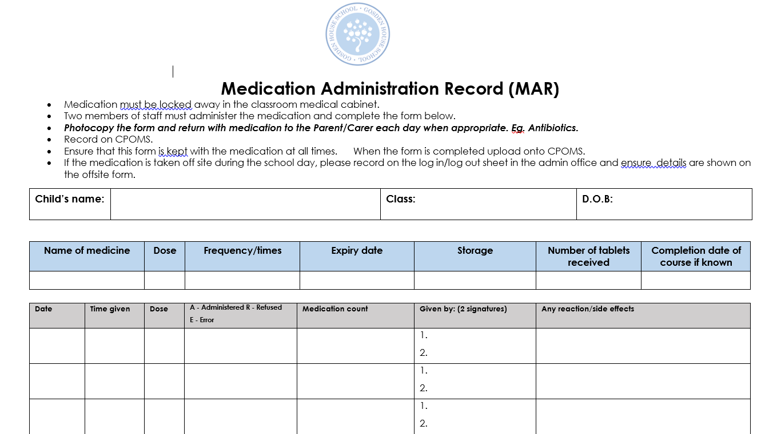

Stored: Staff share2022-2023, Admin, Medical, MAR

Appendix 2
Pupil Medication Request
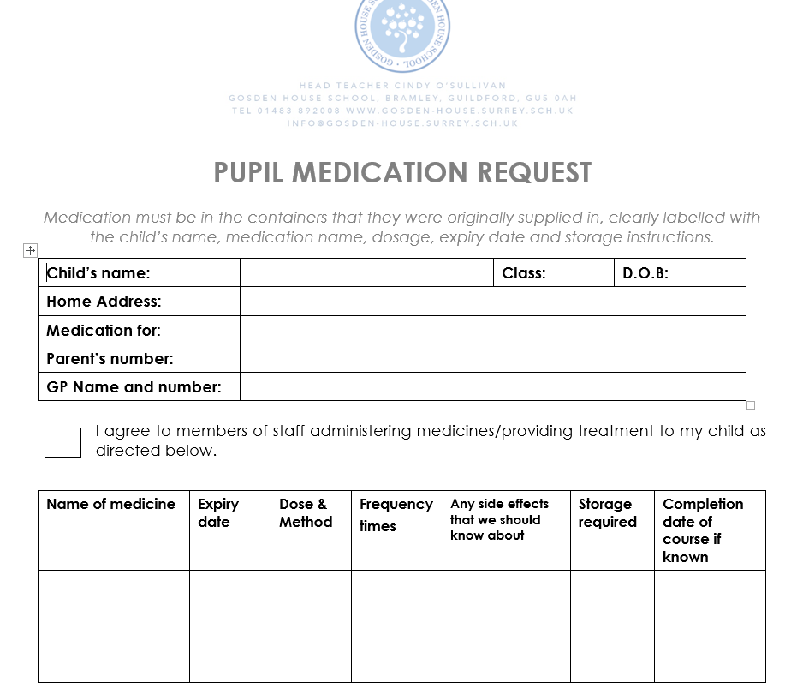
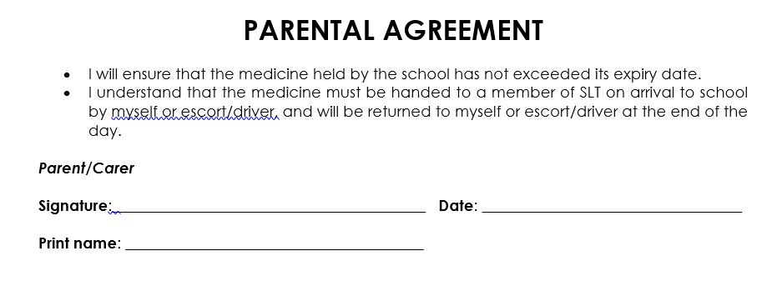
Stored: Staff share 2022 – 2023, Admin, Medical, Pupil Medication Request

Appendix 3
Parent Permission Sheet for Non-Prescribed Medication & Home Medication Information
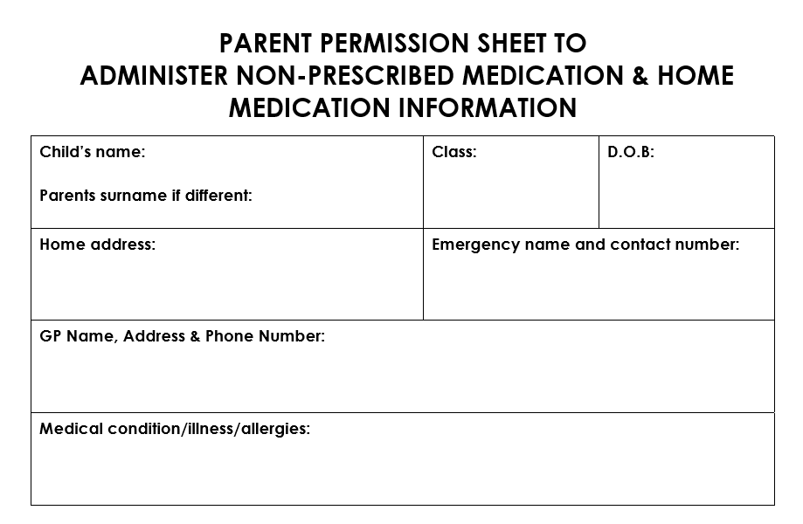
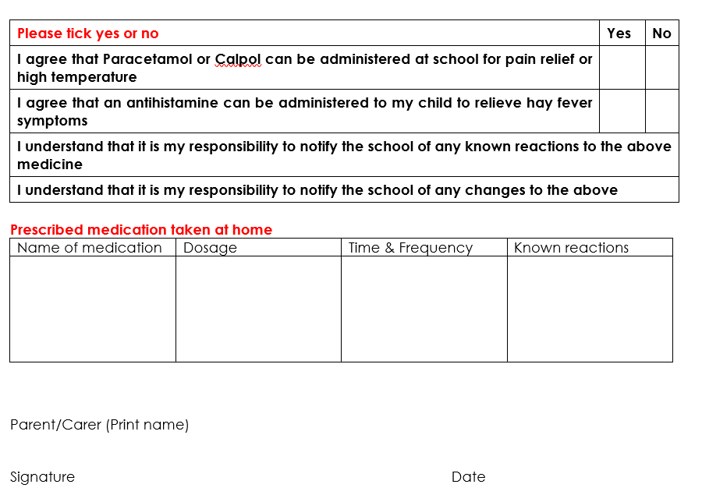

Stored: staff share 2022 – 2023, Admin, Medical, Parent Permission sheet for non-prescribed medication.

Appendix 4
Non-Prescribed Medication Class Record
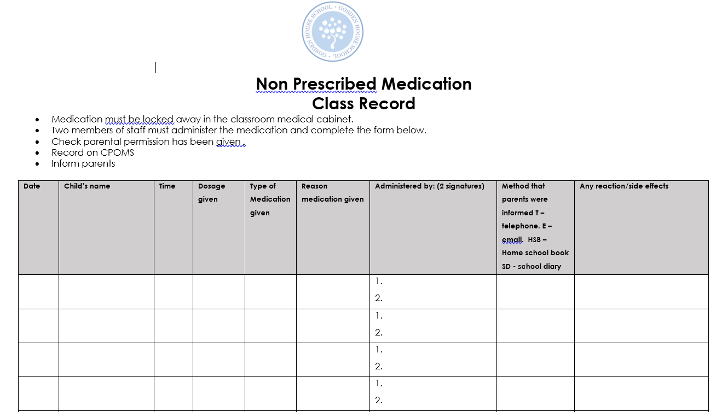

Stored: Staff share 2022 – 2023, Admin, Medical, Non-prescribed Medication class record.

Appendix 5
Staff trained in administering Buccal Midazolam (22/9/22) Training provider: 0-19 Team Waverley, Children and Family Health Surrey
Abi Rainbow Jenkins  Agnes Franchot  Anita Diniz  Anna Windebank  Annette Swindley  Bridget Workman  Caroline McFadyen  Catherine Kneller  Charlotte Almond  Charlotte Willis  Ciaran Timblick  Cindy O’Sullivan  Claire Etherington  Donna Kiy  Donna Shiell  Emily Branch  Emma Songhurst  Emma Barnes  Fathema Amin  Frankie Gale  Germana Baldini  Hayley Butcher  Helen Hutchins  Jo McGee  Jo Southon  Julie Clarke  Juliette Tate  Katherine Johnson  Kelly Carrington  Kerry Bircher  Kieran Wilson | Mandy Attwell  Maria Moon  Max Valentino  Melanie Rainbird  Morgan Emerson  Naomi Hughes  Natalie Downman  Nicola Hall  Nivedita Misra  Sarah Williams  Shannon Enticknap  Sharon Ladd – Thomas  Sophia Philips  Stephanie Wiedemann  Sue Akehurst  Susan Dupuis  Trudy Valentino  Vicky Brooks  Virginia Tasker

Appendix 6
Staff trained Asthma & Anaphylactic Shock
19/10/22 Training provider: 0-19 Team Waverley, Children and Family Health Surrey

Abi Rainbow Jenkins  Agnes Franchot  Anita Diniz  Anna Windebank  Annette Swindley  Bridget Workman  Caroline McFadyen  Catherine Kneller  Charlotte Almond  Charlotte Willis  Ciaran Timblick  Claire Ethrington  Donna Kiy  Donna Shiell  Emily Branch  Emma Songhurst  Emma Barnes  Fathema Amin  Frankie Gale  Germana Baldini  Hayley Butcher  Helen Hutchins  Jo McGee  Jo Southan  Julie Clarke  Juliette Tate  Katherine Johnson  Kelly Carrington  Kerry Bircher  Kieran Wilson | Mandy Attwell  Maria Moon  Max Valentino  Melanie Rainbird  Morgan Emerson  Naomi Hughes  Natalie Downman  Nicola Hall  Nivedita Misra  Sarah Williams  Shannon Enticknap  Sharon Ladd – Thomas  Sophia Philips  Stephanie Wiedemann  Sue Akehurst  Susan Dupuis  Trudy Valentino  Vicky Brooks  Virginia Tasker

Appendix 7
Training provider: 0-19 Team Waverley, Children and Family Health Surrey

Consent for Emergency Salbutamol Inhaler Use

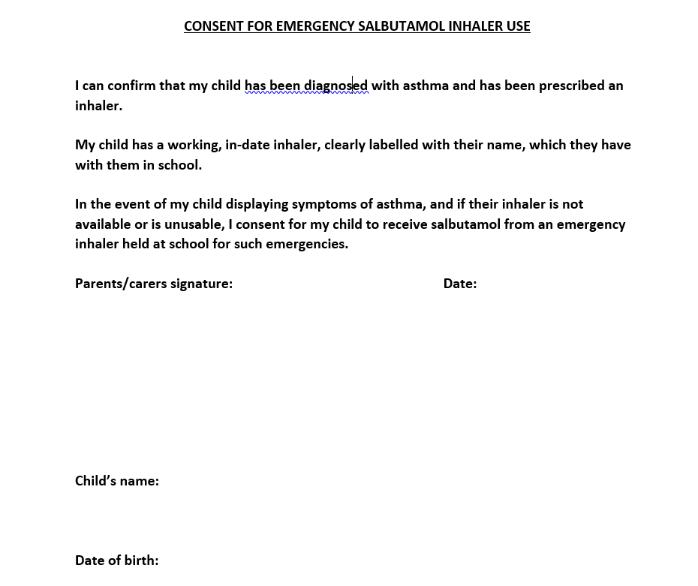
Stored: staff share 2022-2023, Admin, Medication, Salbutamol consent

Appendix 8
What to do in the event of an asthma attack

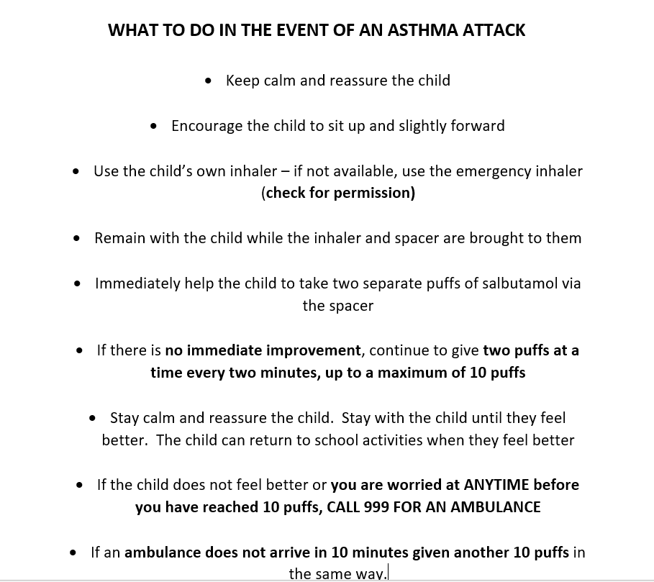

Stored: staff share 2022-2023, Medical guidance.

Appendix 9
How to recognise an asthma attack

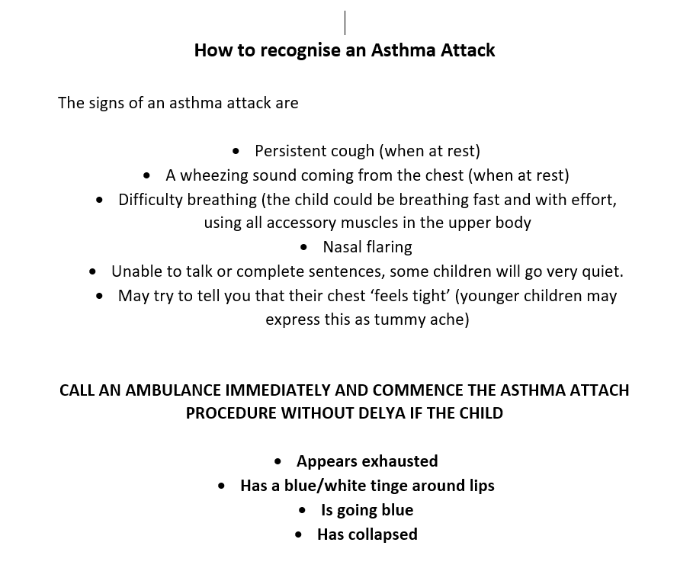
Stored: staff share 2022-2023, Medical guidance.

Appendix 10
Example of how to administer an auto-injector

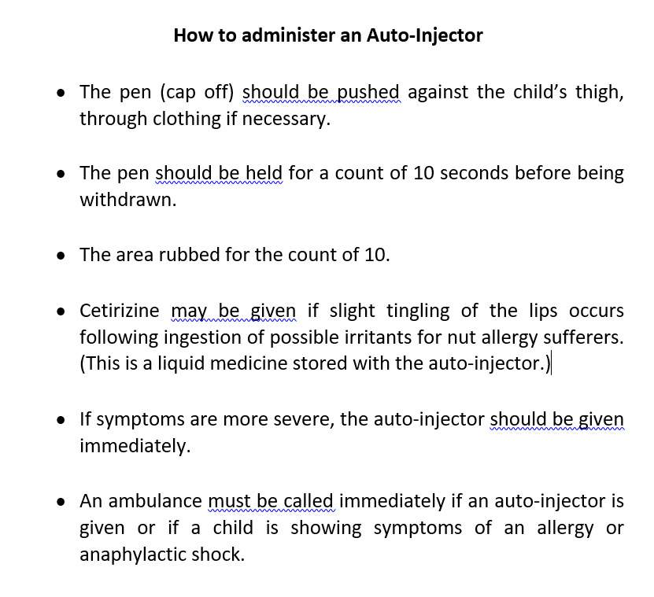

Stored: staff share 2022-2023, Medical guidance.

Appendix 11
Medication Incident Record

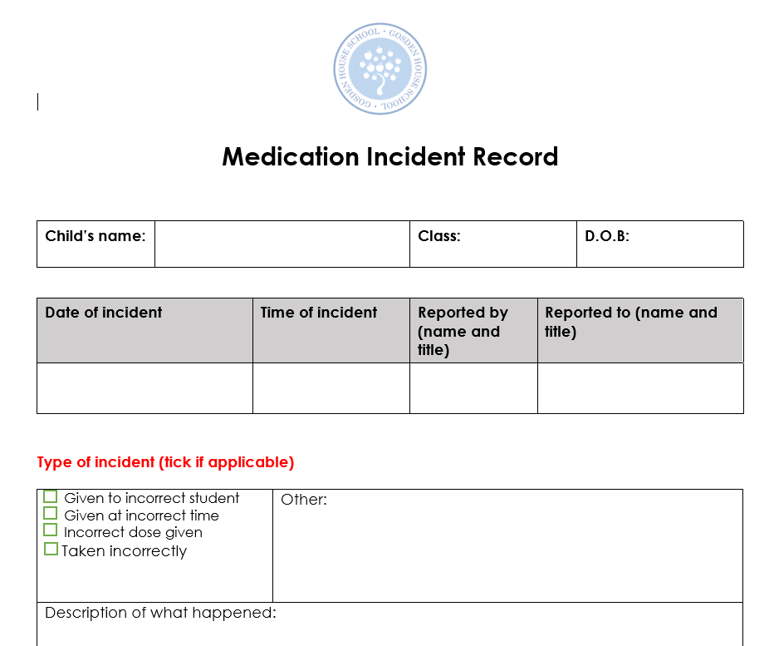
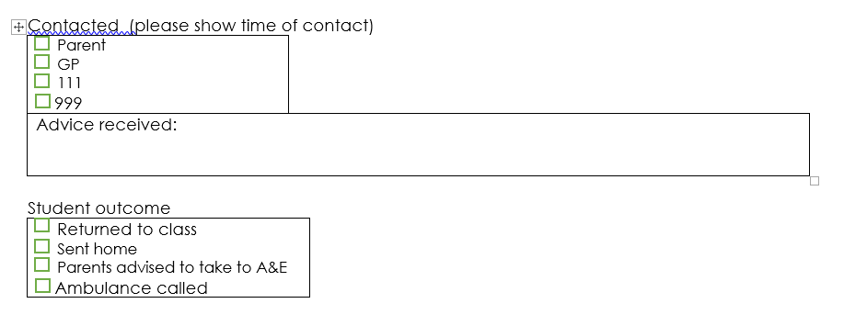

Stored: Staff share 2022 – 2023, Admin, Medical, Medication incident report
Appendix 12
Medical team responsibilities – who does what.

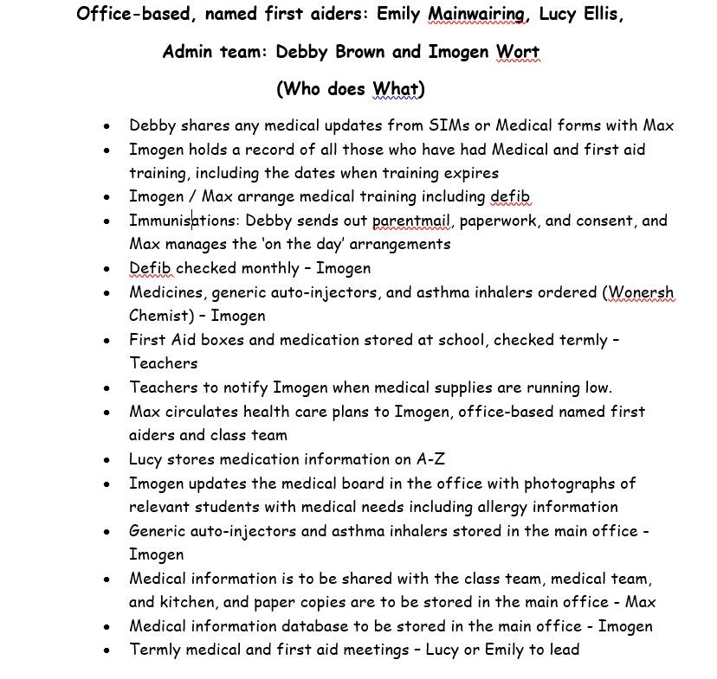

Stored: staff share 2022-2023, Medical guidance.

Appendix 13
Contact List

Name and contact details of outside agency support:
School nurse: Andrea Peagam. Andrea.peagam@nhs.net.
Andrea Peagam
School Nurse
0-19 Team Waverley
Children and Family Health Surrey
Tel: 01483 362631
Mobile: 07920 565442

Epilepsy Nurse: Natalie Barnes

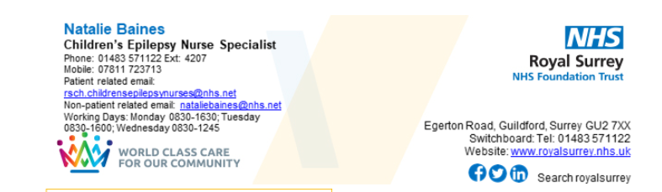
Incontinence Nurse:
Danielle Brennan
Children’s Continence Nurse

Children and Family Health Surrey

Children’s Continence Service
Leatherhead Hospital
Office: 07713094697
Email: csh.childrenscontinence@nhs.net
Mobile 07738 752871
Hours of work: 8-4 pm Tuesday-Friday
danielle.brennan1@nhs.net
Address: Leatherhead Hospital, Poplar Road, Leatherhead, Surrey, KT22 8SD
For further information visit www.childrenshealthsurrey.nhs.uk

Immunisation Team: Emma Zamboni and Val Whiteway
Link chemist: Diana. Wonersh@paydens.com
Wonersh Surgery
The Street
Wonersh
Surrey GU5 0PE

Emma Zamboni
Immunisation Administrator
Immunisation Team
CSH Surrey
Tel: 01483 362566
emmazamboni@nhs.net

Appendix 14
Staff trained in
Medicines Awareness Course for Schools and Early Years
(Foundation Level)

Training provider: Opus 16/11/22

Ciaran Timblick
Naomi Hughes
Kerry Bircher
Juliette Tate
Bridget Workman
Stephanie Wiedemann
Catherine Kneller
Jo McGee
Kieran Wilson
Alex Scott
Vicky Brooks
Sophia Philips
Max Valentino
Hayley Butcher
Emily Branch
Charlotte Almond
Jo Southon

Appendix 15
‘Being returned home’ Log Sheet

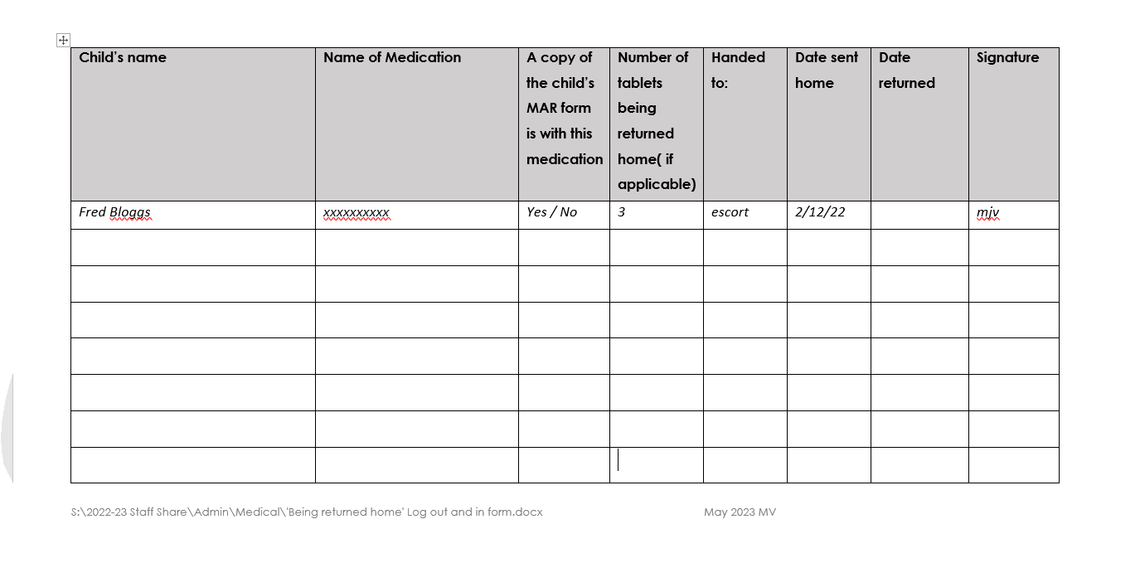

Appendix 16

Staff trained in
St. John’s First Aid at Work (one day)
19/11/22

Agnes Franchot
Anita Diniz
Anna Windebank
Charlotte Willis
Claire Etherington
Donna Shiell
Emma Barnes
Fathema Amin
Germana Baldini
Jane Cowles
Katherine Johnson
Mandy Attwell
Maria Moon
Marion Dunn
Melanie Rainbird
Nivedita Misra
Phoebe Civil
Sarah Williams
Shannon Enticknap
Aliana Purgigiana
Yemurai Kamoto

Appendix 17

Resuscitation Action Plan – Automated External Defibrillator

The defibrillator is to be used in the event that a person is in cardiac arrest i.e. when the heart suddenly stops pumping blood around the body.

In the event that there is only one person on the scene, they should immediately call the emergency services and start CPR immediately afterward.

If there are two people on the scene, one should call the emergency services whilst the other starts CPR. The person administering CPR should not leave the casualty unless absolutely essential. Where possible the defibrillator should be brought to the scene by someone already close to its location, rather than sending somebody to fetch it.

- Member of staff witnessing cardiac arrest to begin CPR, if there is a member of staff close by, that person is to notify the office that an ambulance, first aider and a member of SLT are required, specifying the location.

- First aider to go to the location and support / take over from the member of staff carrying out CPR.

- Office to call Emergency Services and wait for the ambulance to arrive, directing them to the casualty.

- The First Aider to call out on channel 4 (via walk talkie) for defibrillator to be brought to the scene by a member of Foxes Class, or, if quicker:
- The 2nd person walks to gets the defibrillator

Other members of staff to ensure that the scene is kept clear of children

Cardiac arrest
A cardiac arrest is a life-threatening emergency where a person’s heart has suddenly stopped pumping blood around the body. The person will be unconscious, unresponsive and will not be breathing normally or not breathing at all. It is essential to call 999 immediately for an ambulance.

Heart attack
A heart attack happens when a blood clot blocks an artery around the heart...[the person does] not usually lose consciousness and continue breathing. It is vital that you call an ambulance immediately as this is a life-threatening situation. If the person is still conscious, this means their heart is still beating and CPR and/or the use of a defibrillator is not appropriate.

A defibrillator is only appropriate when the heart has stopped beating. If the heart attack deteriorates to a cardiac arrest, then it is appropriate to start CPR and use a defibrillator.

Appendix 18

En-Plug Training regarding S. Street
Trainer Rebecca Murphy 03456 051746

