SECONDARY CURRICULUM
Year 7 Learning Journey 2024-25

Our Secondary Curriculum is driven by the aim to nurture and develop 10 essential ‘Key Life Tools’ (refer to Gosden Graduate Toolbox Doc) in our learners. These ‘Life Tools’ form our ‘Gosden Graduate Toolkit’ and we believe they are essential in preparing our Gosden Learners for their individual pathways post 16. Through ‘tooling up’ our learners we aim to develop a lifelong love of learning, building in them resilience and grit, so that when they leave Gosden House School they are better equipped to face life’s challenges in a world that is forever changing.

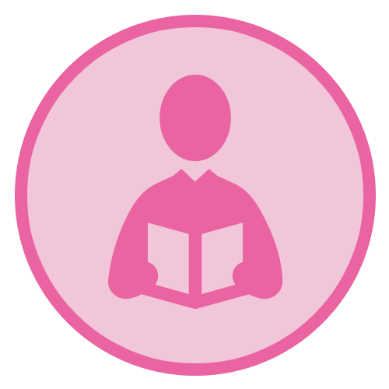 |  |  | 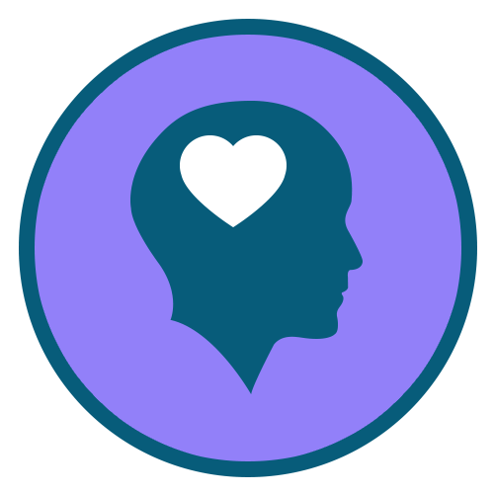 |  | 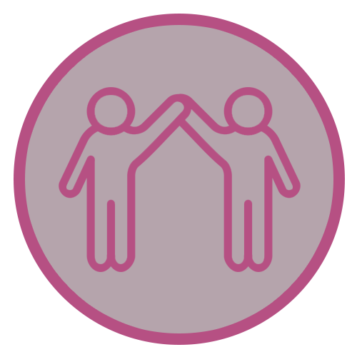 |  | 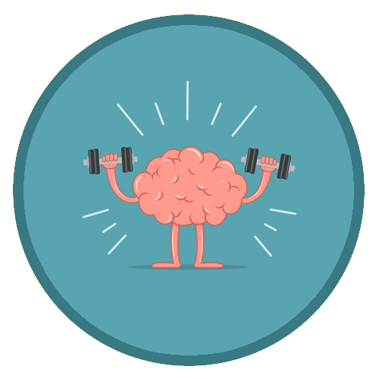 |  | 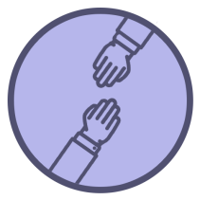
Functional  Literacy  Skills | Functional  Numeracy  Skills | Functional  ICT  Skills | Emotional  Wellbeing | Healthy Lifestyle | Healthy Relationships | Life Skills | Learning Muscles | Employability Skills and Qualifications | Sense of Belonging

Subject | AUTUMN |  | SPRING |  |  | SUMMER
Functional Maths | Throughout their Maths learning journey, our learners will develop skills in the following areas;  Number – Counting forwards and backwards, addition, subtraction, multiplication, division, fractions and place value, number system.  Measure – Time, money, weight, length, capacity and temperature  Geometry – Properties of 2D and 3D shapes including positions and directions  Statistics – Carrying out surveys, interpreting data and presenting data in charts and graphs  Functional Skills – Practical Maths in everyday situations throughout the curriculum.  HOME LEARNING OPPORTUNITIES  Lots of handling money opportunities , spending, budgeting, cooking together and saving pocket money, number based online and board games , wearing a watch and talking about time including days of the week, months and the seasons, reading timetables.  Free online Maths games - Top Marks, Oxford Owl, and Oak National Academy.  Homework  We believe that the purpose of homework is to allow our learners to further their learning in a creative and explorative way. Homework will be set every Friday and will be due the following Friday, it will be a practical activity that will allow them to consolidate their learning from that week. If your child is finding it tricky to complete their homework, please do get in touch as we can support them with their homework at school.
Functional Literacy | As part of their Literacy learning journey, our learners develop their reading, writing and spoken language skills. Our Learners will be exposed to a wide variety of texts such as; Stories, Poetry, Non-fiction and Plays. These texts will be used as ‘vessels’ to enable our learners to access a modified and individualised National Curriculum. A further aspect of their Literacy learning journey, will be explicit lessons dedicated to the teaching of spelling, punctuation and grammar. This will enable our learners to develop their skills in these areas, which they can then use throughout the rest of their learning journey.  HOME LEARNING OPPORTUNITIES  Speaking – answer the phone at home. Practise speaking on the phone by ordering a take-away or booking an appointment.  Listening – Listen to the news (Newsround) on either the radio or the TV; ask questions after listening to gauge their understanding.  Reading – Support with reading food labels. timetables, road signs, instructions.  Writing – Encourage writing thank you notes, postcards, keeping a diary.  Homework  We believe that the purpose of homework is to allow our learners to further their learning in a creative and explorative way. Homework will be set every Friday and will be due the following Friday, it will be a written task that will allow them to consolidate their learning from that week. If your child is finding it tricky to complete their homework, please do get in touch as we can support them with their homework at school.
Computing | Within the Secondary Department, we deliver the Computing Curriculum throughout all subjects. This allows our learners to have many opportunities to engage with technology in a meaningful way, which will allow them to develop their functional ICT skills.  HOME RESOURCES  Touch Typing Practise – BBC Dance Mat  Microsoft Powerpoint – make Powerpoints on areas of interest and then present them to family.  With support and guidance research ‘Our World’ topics and then share research with teacher.  NSPCC online, Child net, internetmatter.com.  Our E-safety Co-ordinator is also available to support and guide parents regarding keeping happy and safe online.
Citizenship | As part of their Citizenship learning journey, our learners will investigate the real meaning of Citizenship, each term will have a specific focus. Please see below some examples of what will be covered.
 | Autumn – Discussion  What is Active Citizenship?  News and current events – watch the news, how to source the news, responding to news – debate etc.  Where to find news – how do we know it is reliable?  Name those in their local community – who is in their class  Discussion – ask for more information to aid understanding, how to discuss the news, share opinions about the news, explain something that happened on the news, sequence a news event, contribute to group discussions |  |  | Spring – Knowing your Local Area  Identify local buildings and their uses.  Name areas in which learners live. What is in their local areas? Share.  Identify groups within the community. Who makes up the community?  Identify community groups which might be of interest to the learner ( they could look into after school enrichments, interview Planet Soccer to find out what clubs they run outside of school etc).  Participate in a positive activity to benefit a community. |  |  | Summer – Recycling and managing waste  Identify different packaging materials  Identify items for recycling  Identify appropriate bins for recycling  Suggest ways to reduce own recycling
Our World | Through the delivery of Our World which incorporates History and Geography. Our aim is to encourage curiosity and creativity in our learners and provide them with real life opportunities for discovery and exploration. This project-based approach supports our learners to develop all of their Learning Muscles.
 | Movement and Migration  Please see below some examples of areas that we will aim to cover. As there will be many opportunities for our learners to take the lead in their project, some of the topics will arise during the planning stages of the project.  - The Windrush Generation  - Cranleigh Local Area Study  - Natural Disasters  - Animal migration  - Infrastructure |  | Food of the Gods  Please see below some examples of areas that we will aim to cover. As there will be many opportunities for our learners to take the lead in their project, some of the topics will arise during the planning stages of the project.  - Fairtrade chocolate  - Ancient Aztecs  - Ancient Mayans  - Chocolate as currency  - Movement of food around the world |  |  | Marvelous Monarchs  Please see below some examples of areas that we will aim to cover. As there will be many opportunities for our learners to take the lead in their project, some of the topics will arise during the planning stages of the project.  - Tudor Monarchy  - Georgian Monarchy  - Local History study of Gosden House  - Crime and Punishment  - Formation of the United Kingdom
P.S.H.E.  (Personal, Social and Health Education) | Autumn 1  My World and the Wider World  Our leaners will explore the idea of community, and consider the benefits of being part of a community. | Autumn 2  Me and My Relationships  Our leaners will explore the idea of role models, and develop their understanding of what makes a positive role model. | Spring 1  Health Lifestyle and Wellbeing  Our learners will explore mental health, and will develop their understanding of how to support their own mental health. |  | Spring 2  Relationships and Sex Education  Our learners will explore the term relationships, and will develop their understanding of different types of relationships. | Summer 1  Relationships and Sex Education  Our learners will explore the term puberty, and will develop their understanding of how our bodies change during puberty. |  | Summer 2  Life Skills  Our learners will develop their Life Skills in a range of areas from cooking to shopping.
Science | Through the delivery of our Science curriculum we ensure that there is a focus on developing key enquiry skills which we believe enable our learners to develop inquisitive and curious minds. Each term there will be a focus, please see some examples of what will be covered below.
 | Our Amazing Bodies  - The Brain – looking at the different parts of the brain and their functions.  - The Digestive System – identifying the different parts and roles within the human digestive system.  - Teeth – identifying the different types of teeth and their functions. |  | Science Lab  - Properties of different materials  - Comparisons of materials for specific uses  - Changes of states – solids, liquids and gases  - Reversible and irreversible changes |  |  | Life in the Allotment  - Environmental changes and the impact on living things  - Life cycles of different animals  - Classification of living things  - Life cycles of plants
R.E. | What helps Hindus (Santanis) to worship?  To investigate the religious practices of Hindus and how these influence home and family life, linking them with important Hindu beliefs.  Why should Hindus live a good life?  To explore what a good life may include and how Hindus make choices according to their religion. |  | Humanism: How do non-religious people celebrate new life?  To explore the beliefs of humanists and how welcoming a new life is important for many people. Learners will draw on their own experiences of milestones and events in their life.  Christianity: What do Christians believe about the Messiah – and why is it good news?’  To explore the connections between the old testament about the Messiah and events from the life of Jesus. |  |  | Christianity: For Christians, what difference does it make to belong to God’s Kingdom?  To understand how Christians believe they are called to live in a way enabled by the Holy Spirit.  What does it mean to live a good life?  To use knowledge of different faiths, religions and encounters, with the experience of life in different communities to answer key questions.  How is God Three – and yet One?  To explore the Christian concept of the Trinity and investigate how some Christians express their ideas and beliefs in words and art.
Creative Arts | Each Wednesday morning our learners take part in a Creative Arts carousel, this incorporates; Drama, Dance, Art & Design, Music and Design and Technology. These lessons are taught by subject specialists and are a fantastic opportunity for our learners to explore their curiosity of the world and to express their individuality and creativity. Our delivery of Creative Arts allows our learners to explore their curiosity of learning and express their thoughts and feelings creatively. Through this experiential approach, we are able to nurture a lifelong love of learning within our learners and equip them with the tools they will need as a Gosden Graduate.
P.E. | As part of their PE journey, our learners will be exposed to a range of different sports. They will learn skills related to each sport, which will enable them to enhance their abilities within that sport. They will explore the importance of a healthy lifestyle, and how this can be maintained.  Autumn Term 1 – Dance and Orienteering  Autumn Term 2 – Gymnastics and Indoor Athletics  Spring Term 1 – Football and Basketball  Spring Term 2 – Tennis and Badminton  Summer Term 1 – Athletics  Summer Term 2 – Cricket and Softball
Textiles | As part of their DT journey, our learners will have a term of Textiles. They will explore different techniques to use for sewing and will use these new skills in their own creations.
Food Studies | Each year group will have a term of Food studies. We will be looking at basic skills, hygiene, and cooking skills. We will be looking at healthy eating, a balanced diet and different food groups.
Enrichment Programme | Enrichment activities play an essential part in enhancing the learning experiences and school life of our learners. These are aimed at developing their life tools including healthy relationships, emotional wellbeing and life skills. Learners are able to select the activities they would like to do, this helps them to further develop their Learning Muscles and become lifelong resilient Learners.

