SECONDARY CURRICULUM
Year 8 Learning Journey 2024-25

Our Secondary Curriculum is driven by the aim to nurture and develop 9 essential ‘Key Life Tools’ (refer to Gosden Graduate Toolbox Doc) in our learners. These ‘Life Tools’ form our ‘Gosden Graduate Toolkit’ and we believe they are essential in preparing our Gosden Learners for their individual pathways post 16. Through ‘tooling up’ our learners we aim to develop a lifelong love of learning, building in them resilience and grit, so that when they leave Gosden House School they are better equipped to face life’s challenges in a world that is forever changing.

 |  |  | 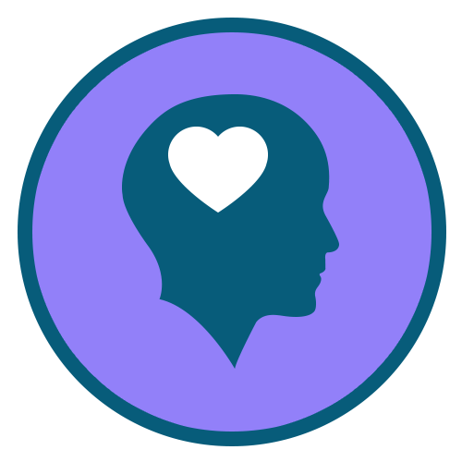 |  | 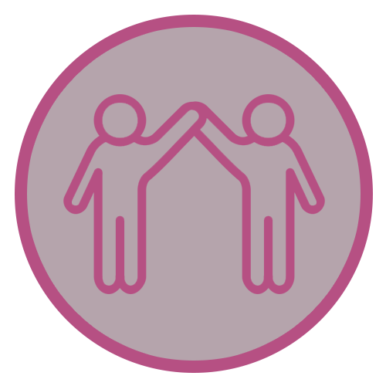 |  | 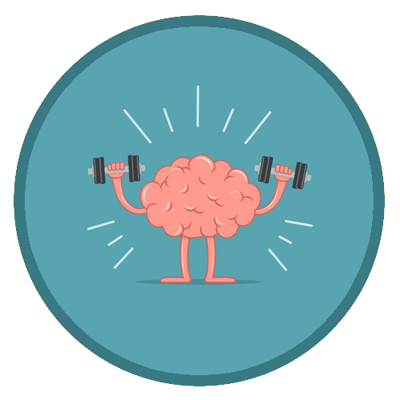 | 
Functional  Literacy  Skills | Functional  Numeracy  Skills | Functional  ICT  Skills | Emotional  Wellbeing | Healthy Lifestyle | Healthy Relationships | Life Skills | Learning Muscles | Employability Skills and Qualifications

Subject | AUTUMN | SPRING | SUMMER
Functional Maths | Throughout their Maths learning journey, our learners will develop skills in the following areas;  Number – Counting forwards and backwards, addition, subtraction, multiplication, division, fractions and place value, number system.  Measure – Time, money, weight, length, capacity and temperature  Geometry – Properties of 2D and 3D shapes including positions and directions  Statistics – Carrying out surveys, interpreting data and presenting data in charts and graphs  Functional Skills – Practical Maths in everyday situations throughout the curriculum.  HOME LEARNING OPPORTUNITIES  Lots of handling money opportunities , spending, budgeting and saving pocket money, number based online and board games , wearing a watch and talking about time including days of the week, months and the seasons, reading timetables.  Free online Maths games - Top Marks, Oxford Owl, and Oak National Academy.
Functional Literacy | As part of their Literacy learning journey, our learners develop their reading, writing and spoken language skills. Our Learners will be exposed to a wide variety of texts such as; Stories, Poetry, Non-fiction and Plays (including Shakespeare). These texts will be used as ‘vessels’ to enable our learners to access a modified and individualised National Curriculum. A further aspect of their Literacy learning journey, will be explicit lessons dedicated to the teaching of spelling, punctuation and grammar. This will enable our learners to develop their skills in these areas, which they can then use throughout the rest of their learning journey.  HOME LEARNING OPPORTUNITIES  Speaking – answer the phone at home. Practise speaking on the phone by ordering a take-away or booking an appointment.  Listening – Listen to the news on either the radio or the TV; ask questions after listening to gauge their understanding.  Reading – Support with reading food labels. timetables, road signs, instructions.  Writing – Encourage writing thank you notes, postcards, keeping a diary.
Computing | Within the Secondary Department, we deliver the Computing Curriculum throughout all subjects. This allows our learners to have many opportunities to engage with technology in a meaningful way, which will allow them to develop their functional ICT skills.  HOME RESOURCES  NSPCC online, Child net, internetmatter.com. BBC online - Dance Mat Typing game  Our E-safety Co-ordinator is also available to support and guide parents.
Citizenship | As part of their Citizenship learning journey, our learners will investigate the real meaning of Citizenship. They will also explore the question; what makes a good citizen? They will consider their environments and the people around them. We will consider some of the things we do at home, at school, in our towns and villages, to improve our own lives and the lives of others. We will also think of ways to be a better citizen and work on some special projects to help our school.
Our World | Through the delivery of Our World which incorporates History, Geography, Languages and Science. Our aim is to encourage curiosity and creativity in our learners and provide them with real life opportunities for discovery and exploration. Each term the Learners will be presented with a question that will spark their creativity and curiosity for the chosen topic. This project-based approach supports our learners to develop all of their Learning Muscles.
 | Invaders and Settlers  History –  - The Anglo-Saxons  - 1066 and the Battle of Hastings  - The Norman Conquest  Geography –  - Resources needed for a settlement  - Inuit Settlement  - Favelas of Rio de Janeiro | Victorian Life – the Good, the Bad and the Ugly  History –  - New machines – the Industrial Revolution  - Child Labour in the factories and mines  Geography –  - Population growth  - Urbanisation  - Economic development | Voyages of Discovery  History –  - Journeys to Africa, Asia and Australia  - Christopher Columbus and the Discovery of the Americas  - The Native Americans  Geography –  - Oceans  - Coasts and erosion  - Field work trip to West Wittering
Science | Light and Sound  - Pitch and volume  - How sound travels  - Reflection and shadows  - How light travels | Forces and Electricity  - Gravity  - Friction  - Electricity  - Magnetism  - Mechanisms to alter forces | Amazing Adaptions  - Living things and their habitats  - What living things need to survive  - Evolution  - Inheritance
P.S.H.E.E/  (Personal, Social, Health and Economic Education) | My world & the wider world  What a community is  Benefits and problems in communities  The online community  Me and my relationships  Different types of relationships  Healthy and unhealthy relationships  Problems in friendships and relationships and how to solve them.  Role Models  Kind online communication | Health lifestyle and wellbeing  Healthy eating  Health and hygiene.  How to care for our mental health  Relationships and Sex Education  Puberty  Periods & wet dreams  Naming body parts and sexual organs | Life skills  How to ask for help if I have a problem online.  How to make a snack for myself or others  How to write a shopping list  How to contact the emergency services  Relationships and Sex Education  Body image  Consent/privacy  Keeping safe  Relationships
R.E. | What is the nature of God?  - Is there a God?  Christian idea of the Trinity  What is the ‘Buddhist way of life’?  - Buddhism | How should we lead a good life?  CHRISTIANITY  - For Christians, what difference does it make to belong to God’s Kingdom?  - What do Christians believe about the Messiah – and why is it good news? | Is life a journey?  JUDAISM  - What does it mean to be part of a synagogue community?  ISLAM  - What helps Muslims to live a good life?
Creative Arts | Year 8 will take part in a creative arts carousel. This will include drama, music and art sessions, focusing on the ‘Our World’ theme of Guildford and rivers.
P.E. | Netball & Basketball | Multi-skills & Football | Rounders & Athletics
Enrichment Programme | Enrichment activities play an essential part in enhancing the learning experiences and school life of our learners. These are aimed at developing their life tools including healthy relationships, emotional wellbeing and life skills. Learners are able to select the activities they would like to do, this helps them to further develop their Learning Muscles and become lifelong resilient Learners.

