SECONDARY CURRICULUM
Year 9 Learning Journey 2024-25

Our Secondary Curriculum is driven by the aim to nurture and develop 10 essential ‘Key Life Tools’ (refer to Gosden Graduate Toolbox Doc) in our learners. These ‘Life Tools’ form our ‘Gosden Graduate Toolkit’ and we believe they are essential in preparing our Gosden Learners for their individual pathways post 16. Through ‘tooling up’ our learners we aim to develop a lifelong love of learning, building in them resilience and grit, so that when they leave Gosden House School they are better equipped to face life’s challenges in a world that is forever changing.

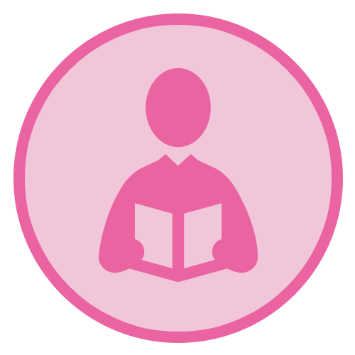 |  | 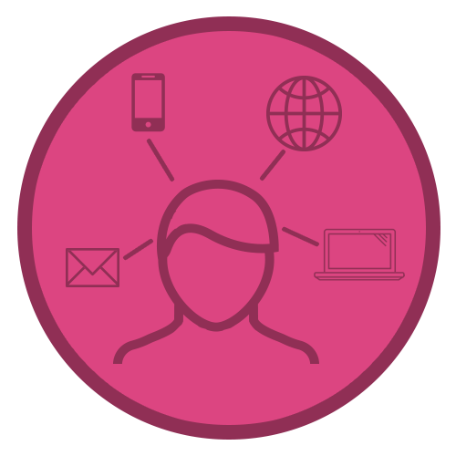 | 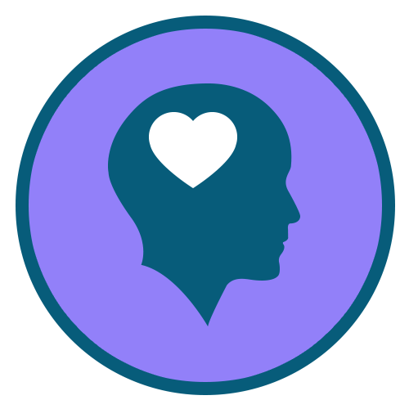 | 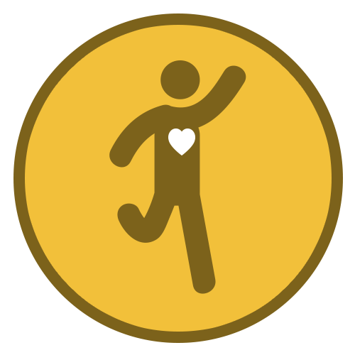 | 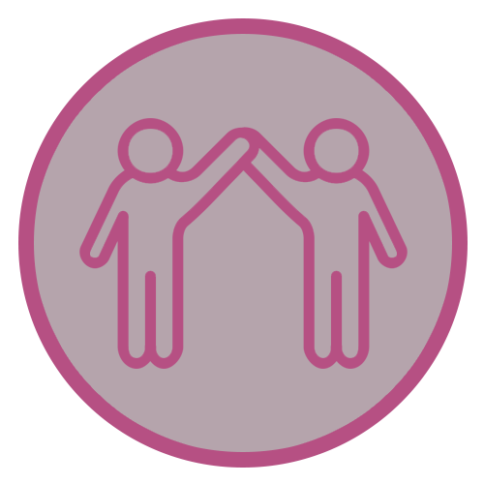 |  | 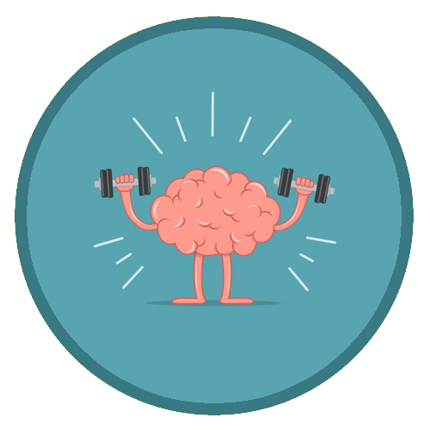 |  | 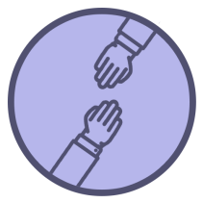
Functional  Literacy  Skills | Functional  Numeracy  Skills | Functional  ICT  Skills | Emotional  Wellbeing | Healthy Lifestyle | Healthy Relationships | Life Skills | Learning Muscles | Employability Skills and Qualifications | Sense of Belonging

Subject | AUTUMN | SPRING | SUMMER
Functional Maths | Throughout their Maths learning journey, our learners will develop skills in the following areas;  Number – Counting forwards and backwards, addition, subtraction, multiplication, division, fractions and place value, number system.  Measure – Time, money, weight, length, capacity and temperature  Geometry – Properties of 2D and 3D shapes including positions and directions  Statistics – Carrying out surveys, interpreting data and presenting data in charts and graphs  Functional Skills – Practical Maths in everyday situations throughout the curriculum.  HOME LEARNING OPPORTUNITIES  Lots of handling money opportunities , spending, budgeting and saving pocket money, number based online and board games , wearing a watch and talking about time including days of the week, months and the seasons, reading timetables.  Free online Maths games - Top Marks, Oxford Owl, and Oak National Academy.  Homework  We believe that the purpose of homework is to allow our learners to further their learning in a creative and explorative way. Homework will be set every Friday and will be due the following Friday, it will be a practical activity that will allow them to consolidate their learning from that week. If your child is finding it tricky to complete their homework, please do get in touch as we can support them with their homework at school.
Functional Literacy | As part of their Literacy learning journey, our learners develop their reading, writing and spoken language skills. Our Learners will be exposed to a wide variety of texts such as; Stories, Poetry, Non-fiction and Plays (including Shakespeare). These texts will be used as ‘vessels’ to enable our learners to access a modified and individualised National Curriculum. A further aspect of their Literacy learning journey, will be explicit lessons dedicated to the teaching of spelling, punctuation and grammar. This will enable our learners to develop their skills in these areas, which they can then use throughout the rest of their learning journey.  HOME LEARNING OPPORTUNITIES  Speaking – answer the phone at home. Practise speaking on the phone by ordering a take-away or booking an appointment.  Listening – Listen to the news on either the radio or the TV; ask questions after listening to gauge their understanding.  Reading – Support with reading food labels. timetables, road signs, instructions.  Writing – Encourage writing thank you notes, postcards, keeping a diary.  Homework  We believe that the purpose of homework is to allow our learners to further their learning in a creative and explorative way. Homework will be set every Friday and will be due the following Friday, it will be a written task that will allow them to consolidate their learning from that week. If your child is finding it tricky to complete their homework, please do get in touch as we can support them with their homework at school.
Computing | Within the Secondary Department, we deliver the Computing Curriculum throughout all subjects. This allows our learners to have many opportunities to engage with technology in a meaningful way, which will allow them to develop their functional ICT skills.  HOME RESOURCES  NSPCC online, Child net, internetmatter.com.  Our E-safety Co-ordinator is also available to support and guide parents.
Citizenship | As part of their Citizenship learning journey, our learners will investigate the real meaning of Citizenship. They will also explore the question; what makes a good citizen? They will consider their environments and the people around them. We will consider some of the things we do at home, at school, in our towns and villages, to improve our own lives and the lives of others. We will also think of ways to be a better citizen and work on some special projects to help our school.
Our World | Through the delivery of Our World which incorporates History, Geography and Languages. Our aim is to encourage curiosity and creativity in our learners and provide them with real life opportunities for discovery and exploration. Each term the Learners will be presented with a question that will spark their creativity and curiosity for the chosen topic. This project-based approach supports our learners to develop all of their Learning Muscles.
 | Why do we have wars?  Pupils will have to opportunity to explore and develop their understanding of why wars begin the lessons to be learnt and the impact of war on people’s lives both now and in the past.  Please see below some examples of areas that we will aim to cover. As there will be many opportunities for our learners to take the lead in their project, some of the topics will arise during the planning stages of the project.  History-  - the First World War and the Peace Settlement  - the Second World War and the wartime leadership of Winston Churchill  - Key events in both the First and Second World War.  - What life was like for Children during the Second World War.  Geography- Look at the countries involved in the wars and how territory changes over time. How did areas change? How did it affect where people lived?  Languages- Looking at historical resources in different languages. Look at propaganda posters from other countries and translate words. | Middle Ages and Microbes  Pupils will have the opportunity to learn about the challenges of life in the middle ages and make comparisons to life today. Pupils will track the spread of the plaque across Europe and learn about medical discoveries.  Please see below some examples of areas that we will aim to cover. As there will be many opportunities for our learners to take the lead in their project, some of the topics will arise during the planning stages of the project.  History – Medicine through time.  - Find out about the life and times of Edward Jenner who created the world’s first vaccine.  - Learn about Alexander Flemming  - COVID-19  - Spread of the black death across Europe,  - Peasant Life,  - Nursery Rhymes – Ring a Ring a Roses  Geography – Spread of Covid-19 and the impact it has on people, the economy and the environment. Research China where Covid-19 originated. Compare a country with a high covid rate and a low covid rate and discuss why this might be.  Also look at how the Black Death spread across Europe. Where are these countries and can we find them on a map?  Language- Look at the Chinese language and written letters. Compare to English. Also look at the origins of Nursery Rhymes and why they were written. | Human Rights  Pupils will be able to explore how human rights have changed for different groups of people over time and what our individual rights look like today depending on who we are and where we live in the world.  Please see below some examples of areas that we will aim to cover. As there will be many opportunities for our learners to take the lead in their project, some of the topics will arise during the planning stages of the project.  History – Human Rights, Slave trade, Suffragettes, Stonewall, Equal Pay, EQUALITY and LGBTQ+ rights  Geography – Is fair trade even fair?  Borders of countries – how they’ve changed  Languages – Different languages spoken in the United Kingdom
P.S.H.E.E/  (Personal, Social, Health and Economic Education) | Me and my relationships  I know what bullying is  I know that is wrong to bully someone  I know how to ask for help if I am being bullied  I know how to be kind to others  I know what racism is  I know it is wrong to treat people differently because of the colour of their skin  Life skills  I know how to ask for help if something online worries me  I know what personal hygiene is  I know how to use deodorant  I know when I need to wash myself  I can make a hot drink independently  Basic First Aid skills | My world & the wider world  I can name some local communities  I can think of a community I would like to join  I can celebrate my own mistake  I know that I can keep trying when I make a mistake  I can plan again when I have made a mistake (task orientated)  Relationships and Sex Education  In RSE we recap changes our bodies go through during puberty, we talk about pregnancy and how babies are made. We also make ‘flour babies’ which we look after for a week to see how having a baby changes your life. | Health lifestyle and wellbeing  I can sequence a familiar routine  I can plan my bedtime routine with support  I can plan my morning routine with support  I know that there are no ‘good’ or ‘bad’ foods (all food gives you energy and is OK in balance)  I know that food gives me energy  I know that my body is not the most important part of me  I know what mindfulness is  I know some ways I can feel mindful  I know what metal health is  I know my mental health is as important as my physical health  I know some ways to care for my mental health  Relationships and Sex Education  We have a big focus on consent and being ready for dating and sex and that it is illegal to have sex before the age of 16. We discuss sexual attraction and how to manage this and diversity in sexuality and sexual attraction.
Science | Our Science curriculum will be taught separately to Our World sessions this year, although, they often link to and support learning in our other subjects. We will have the opportunity to plan and take part in many different investigations and draw conclusions from our findings.
 | Keeping Healthy  Nutrition and digestion;  - Healthy human diets and food groups  - Consequences of imbalances in diet- obesity and starvation  - The Human Digestive system  - Plants and photosynthesis  - Factors affecting plant growth  Health  - Effects of vaping, smoking, energy drinks and alcohol on behaviour health and life processes. | Bacteria and Cells  - Functions of a cell and the parts within a cell  - Names of the parts of a cell  - The differences between animal and plant cells  - Adaptations of unicellular organism  - Hierarchy of multicellular organisms  - Diffusion and movement of materials between cells | Our Bodies  The skeletal and muscular systems;  - The structure and functions of the human skeleton  - How muscles and the skeleton work together  - The function of muscles and muscle pairs  Reproduction;  - Plant reproductions  - Structure plants and flowers  - Human reproductive system  - Menstrual cycle  - Effect of maternal lifestyle on the foetus
R.E. | Islam  What does it mean to be a servant of Allah?  What virtues make a good character?  What makes a good leader in society?  What effect on society might there be if everyone saw themselves as  servants?  Christianity  How are Christians active in society?  How can I change the world for the better?  How do we know what is right? | Christianity  Who was Jesus?  What impact does the concept of self-sacrifice have on my own life?  What is truth?  Humanism  What does it mean to be good?  How can we make society better?  Can we increase empathy?  What kind of society would humanists like to live in? | Christianity  What are some Christians’ responses to persecution?  What does courageous advocacy mean to me?  As a society, do we have a moral obligation to help those who are being persecuted?  Should Christians expect to be persecuted?  Sikhism  How do Sikh people express their faith?  Why is the Amrit Pahul Ceremony important to Sikhi people?  What is the significance of the Five Takhts?  How do we build a good community?  Why should we help others?
Creative Arts | Through Music, Drama and Art we will be looking to build upon the topics we are studying in Our World. In Art we will be exploring war time artists and how the war affected the art work they produced. In Music we will be playing instruments to make songs linked to our Topics and we will also have the opportunity to take part in choir sessions learning exciting songs. Through drama we will look to enhance our learning of ‘Human rights’ and also link in our English learning. It gives us a great opportunity to act in role and think about how others might be feeling.
Careers | The Year 9 Careers curriculum is delivered through discrete weekly sessions, a programme of events, assemblies and class based activities throughout the year. The secondary curriculum focuses on the development of key life tools that are needed to be a successful Gosden Graduate and these life tools are signposted and talked about in lessons. All tutor bases have ‘Class Jobs’ and pupils are encouraged to apply for these roles. We hold a yearly Careers Week where pupils can research and experience different elements of the world of work. In our weekly sessions, we work on completing the unit ‘Learning about workplaces’ in readiness for KS4. We learn that there are different work places and different jobs. We match skills and qualifications needed for different jobs and see how these relate to the Gosden toolkit. We also look at our own skills and personal qualities to think about which jobs would suit us well.
P.E. | Dance and Orienteering  Yoga and Gymnastics | Football and Basketball  Tag Rugby | Athletics  Cricket and Tennis
DT | Through our DT sessions we will be looking at textiles and different sewing techniques and stitches. We will also have the opportunity to investigate resistant materials and learn how to use some of the machines in our DT room correctly and safely.
Food Studies | Each year group will have a term of Food studies. We will be looking at basic skills, hygiene, and cooking skills. We will be looking at healthy eating, a balanced diet and different food groups.
Enrichment Programme | Enrichment activities play an essential part in enhancing the learning experiences and school life of our learners. These are aimed at developing their life tools including healthy relationships, emotional wellbeing and life skills. Learners are able to select the activities they would like to do, this helps them to further develop their Learning Muscles and become lifelong resilient Learners.

